**Project: Building an Intelligent Health Monitoring & Heart Attack Prediction System Using AWS EMR, SageMaker, Lambda, Athena, and SNS**

**Ishwariya pandi**

**ASU Id: 1233885850**

**Information Technology, Arizona State University**

**IFT 512: Advanced Big Data Analytics/AI**

**Durgesh Sharma**

**11/23/2025**

**Project: Building an Intelligent Health Monitoring & Heart Attack Prediction System Using AWS EMR, SageMaker, Lambda, Athena, and SNS**

1. **Project description**

**The Heart Health Alert System** is a complete cloud-based solution built to simulate real-time patient monitoring. It collects and processes daily vital signs, trains a machine learning model, and automatically generates alerts for patients who may be at risk of a heart attack. The system reflects how hospitals can use wearable sensors or clinical devices to track patient vitals continuously.

By combining simulated vital data with historical patient information, an **XGBoost model** is trained in **Amazon SageMaker** to predict heart attack risk levels. A **Lambda function** regularly calls the deployed SageMaker endpoint to score new records and, through **Amazon SNS**, sends automatic email notifications for high-risk patients.

This project demonstrates how multiple AWS services like **S3, EMR (Spark), SageMaker, Lambda, and SNS**. Can be integrated to build a fully automated, scalable, and intelligent healthcare alert pipeline.

**b. Datafile description**

This project uses several connected datasets created at different stages.

In **Phase 1**, the file **simulated_vitals.csv** contains seven days of patient vitals such as heart rate, blood pressure in “systolic/diastolic” format, sleep hours, and physical activity. This data imitates daily readings collected from wearable health devices.

The **heart_attack_prediction_dataset.csv** file serves as the **historical dataset**, providing more patient details like age, sex, country, continent, BMI, cholesterol, diabetes, family history, and a heart-attack risk label.

In **Phase 2**, both datasets are combined and processed to create **final_health_dataset.csv**, which holds the weekly averages of vitals along with the historical patient information. This dataset is ready for model training.

During **Phase 3**, the system also generates a file called **feature_list.txt**, a list of all input features used by the model. This helps keep the data in the same order during predictions.

Finally, **Phase 4** produces result files saved in **predictions/*.csv**, which include each patient’s ID, their predicted heart-attack risk score, the risk level (High or Low), and a timestamp showing when the prediction was made. This helps track the alerts and monitor the system’s performance.

**c. Required Screenshots:**

**S1: Upload Simulated Data to S3  
Creating bucket**  
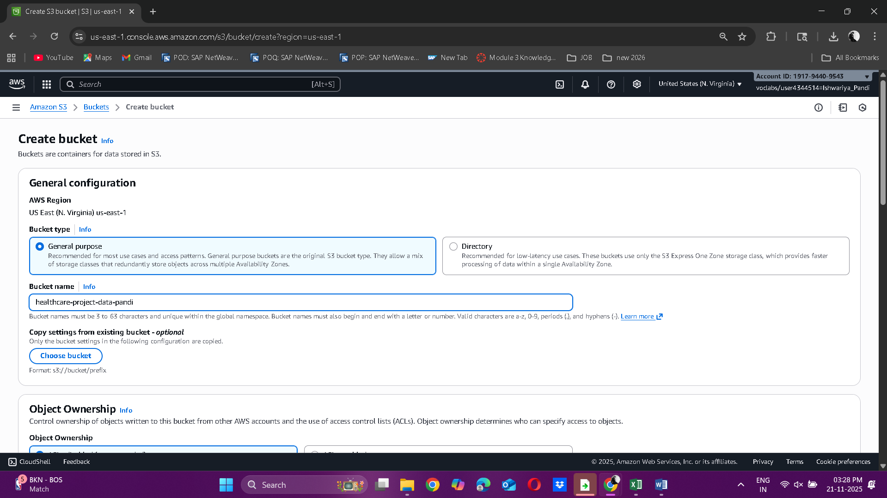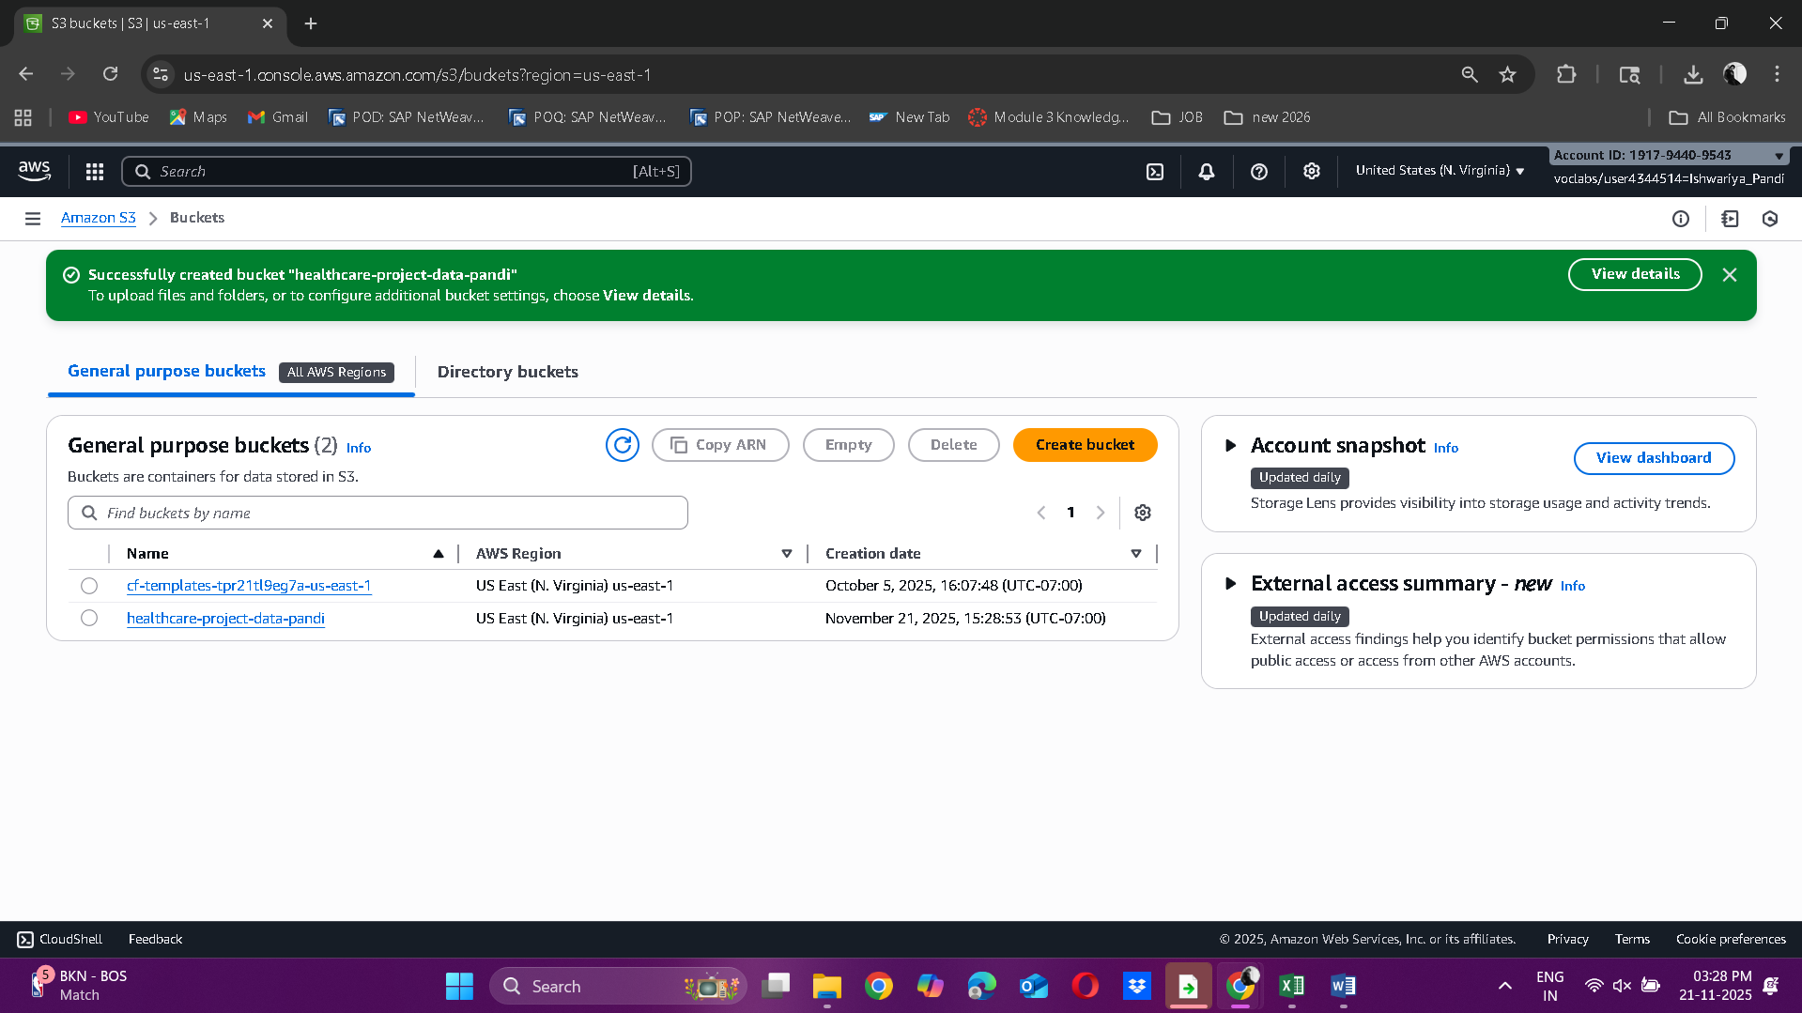 **creating raw folder**   
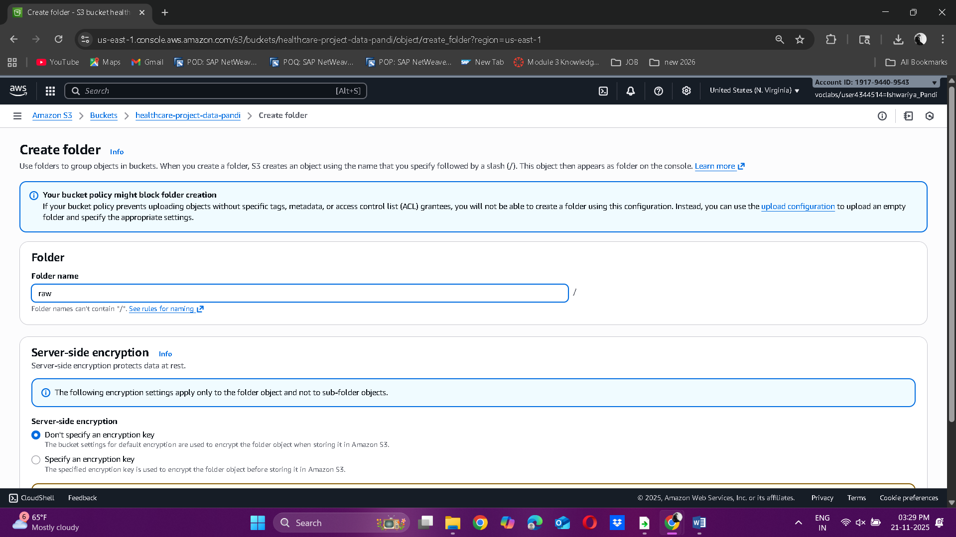

**Creating historical folder**  
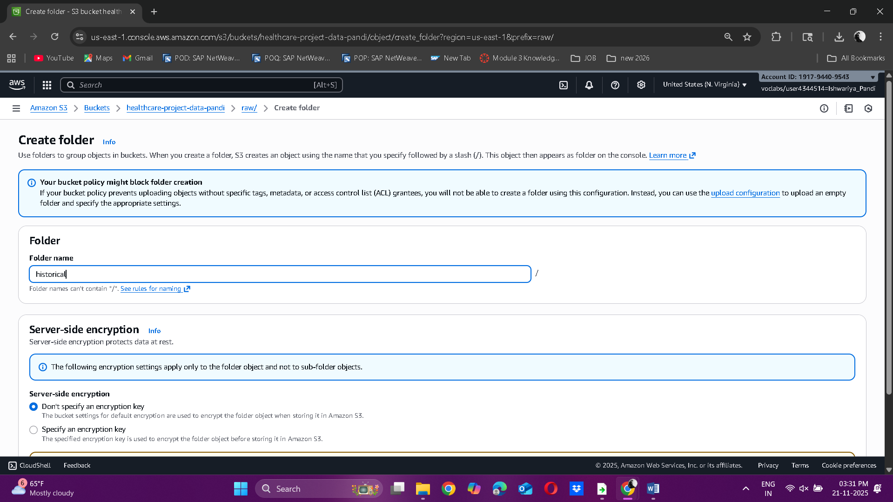  
  
**Uploading the dataset to S3**  
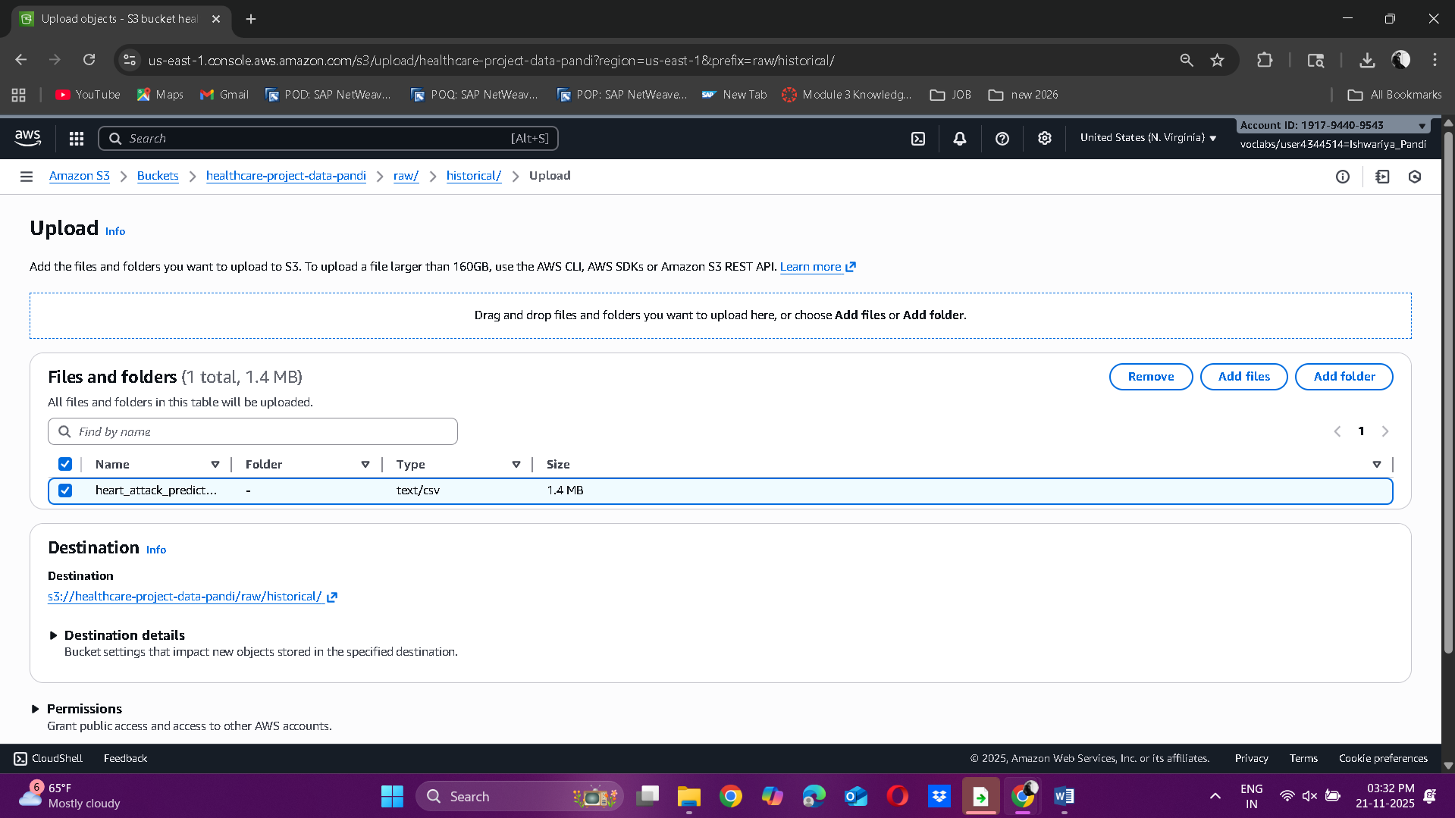  
  
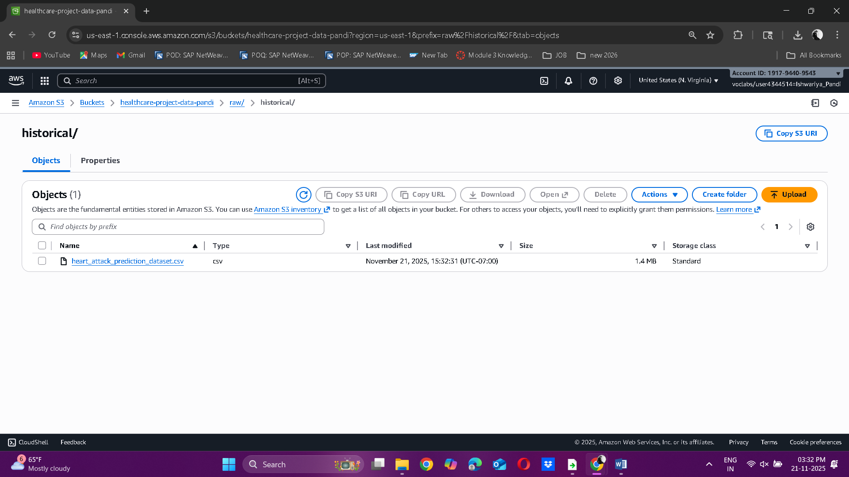

**Running phase 1 script:**  
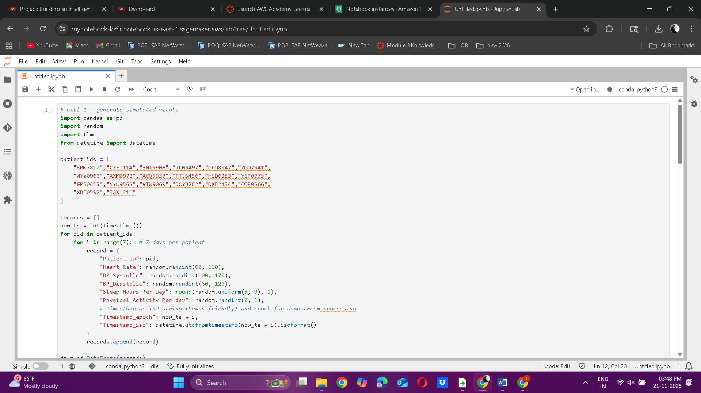

**Generating Simulated_vitals.csv**  
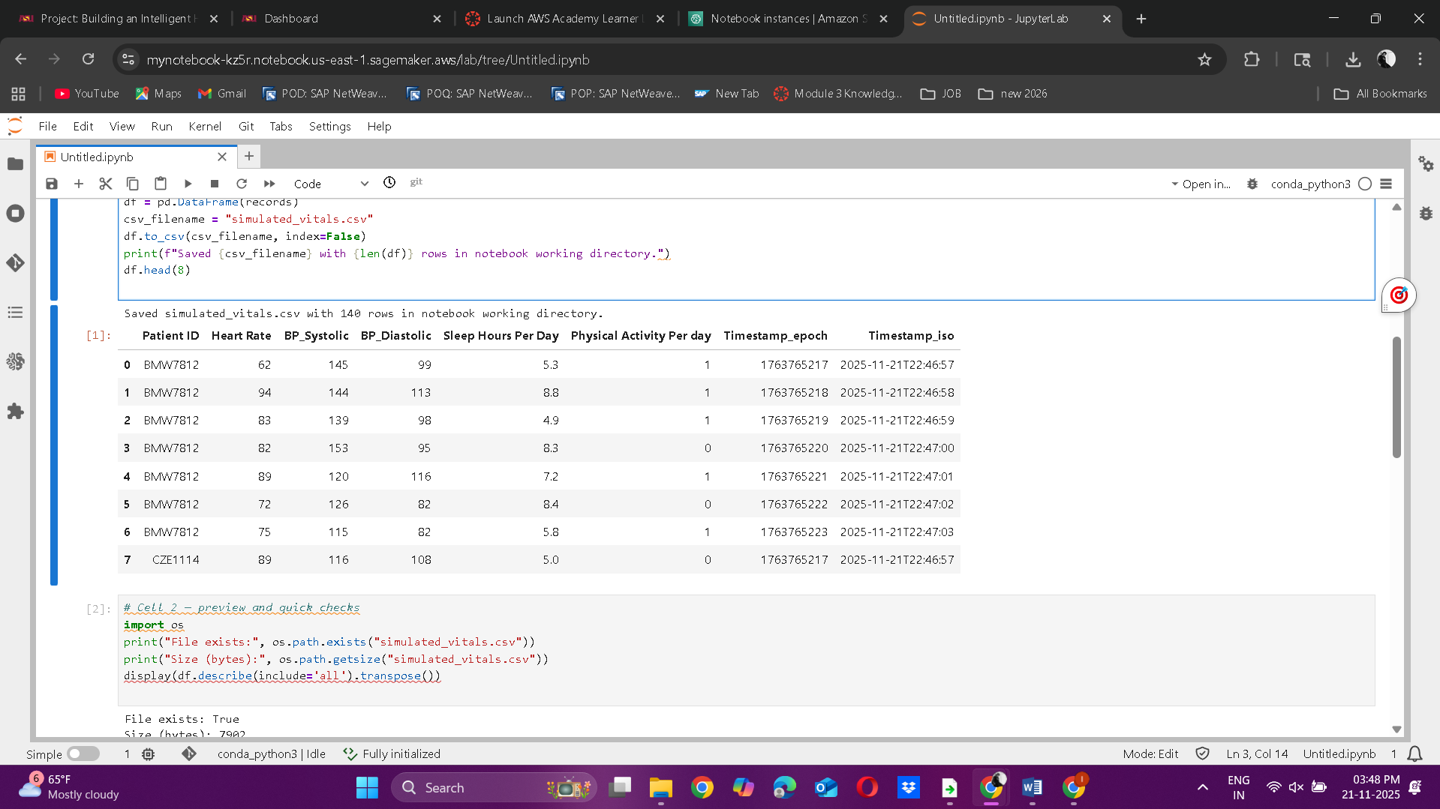  
  
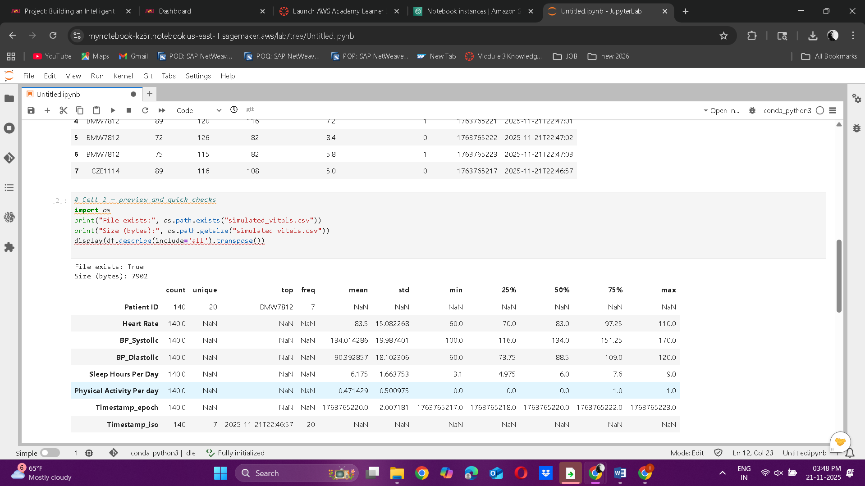  
  
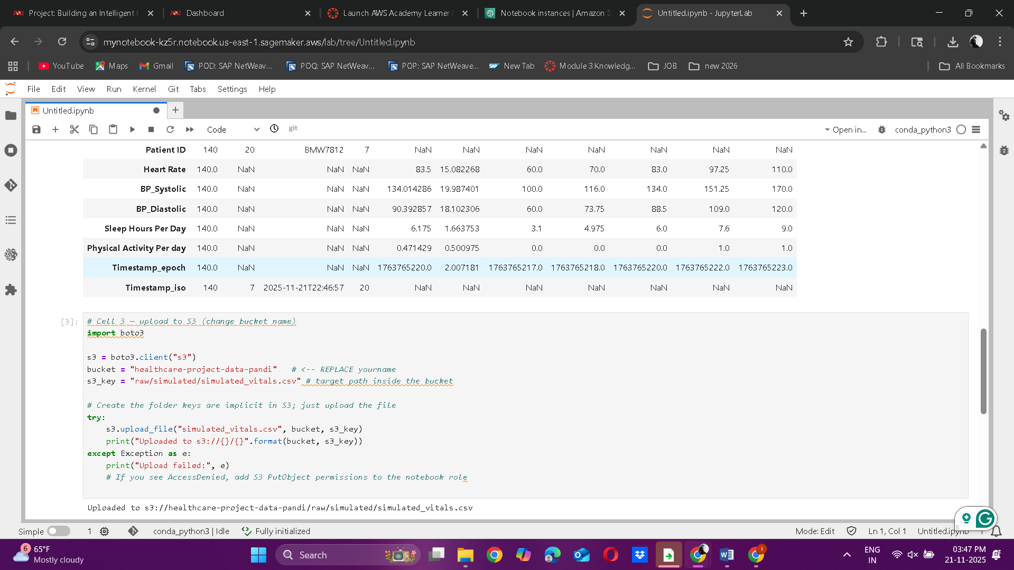  
  
 **CSV getting uploaded in S3**  
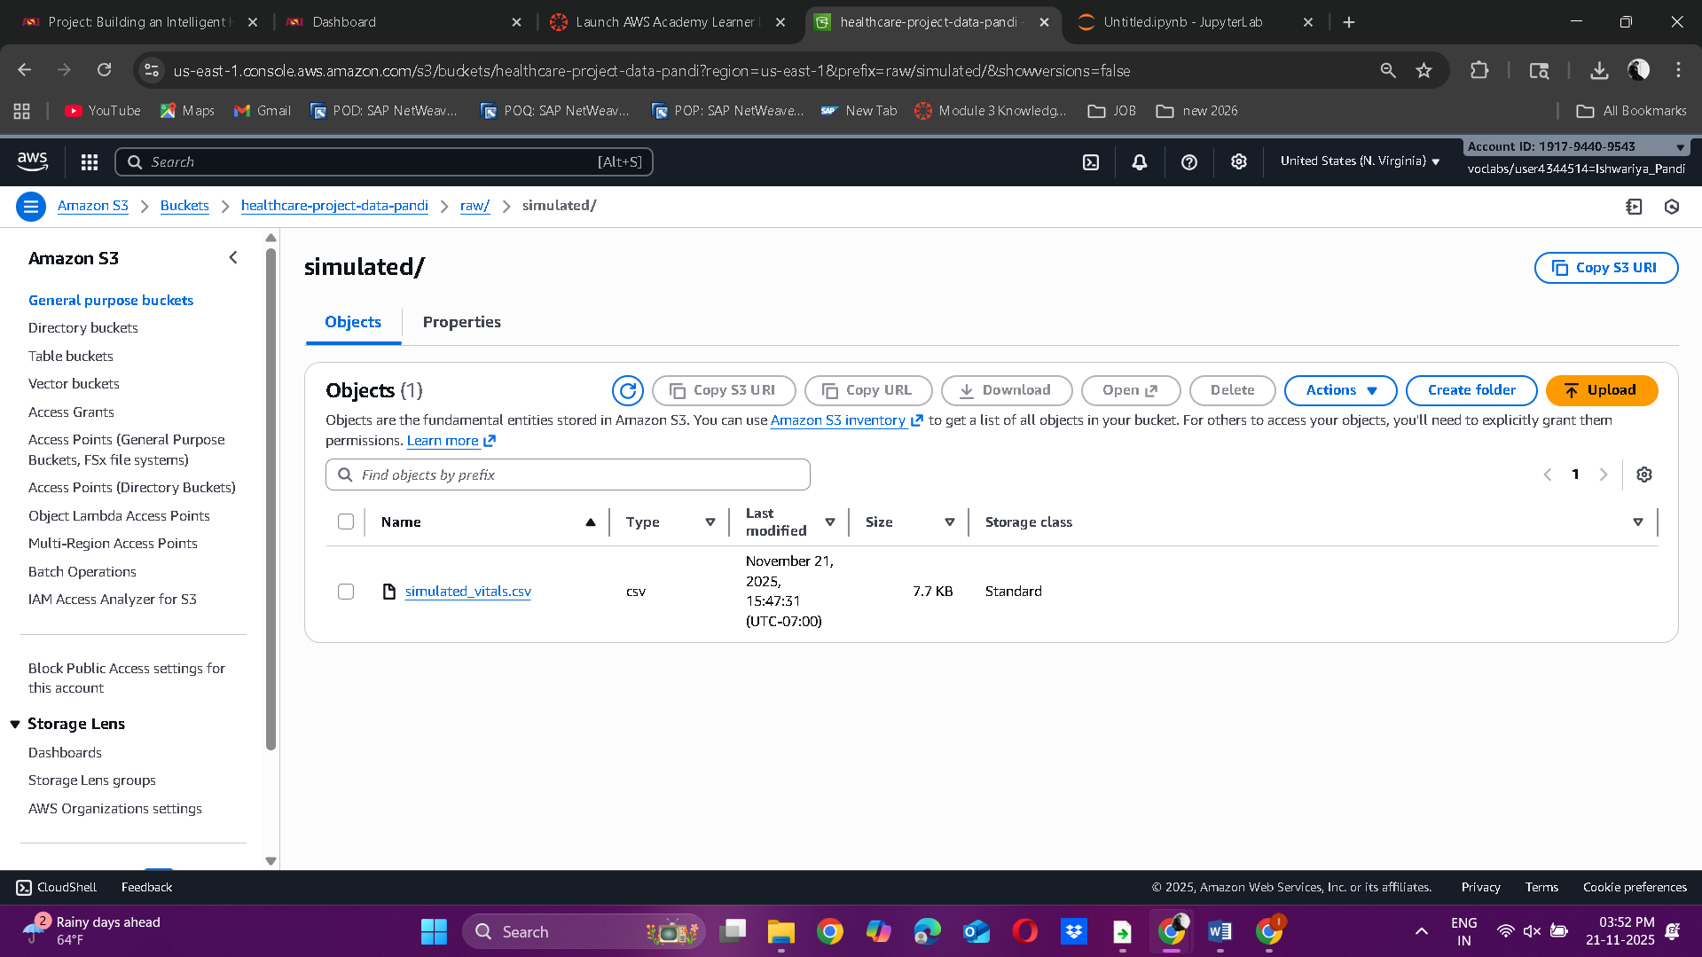  
  
**S2: Cluster Creation**  
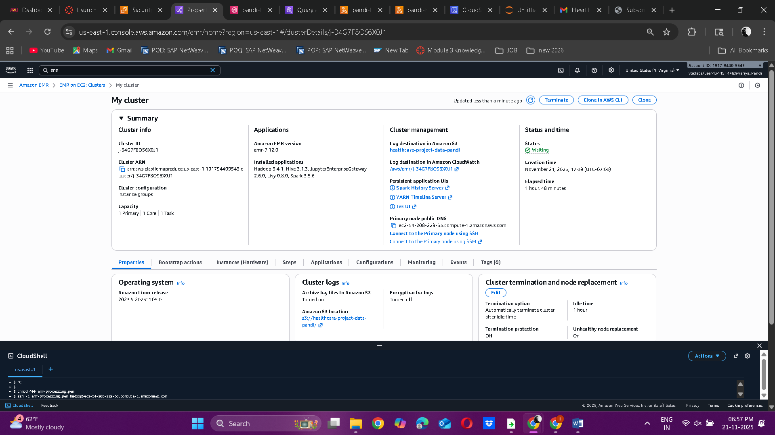  
  
  
  
  
  
  
  
  
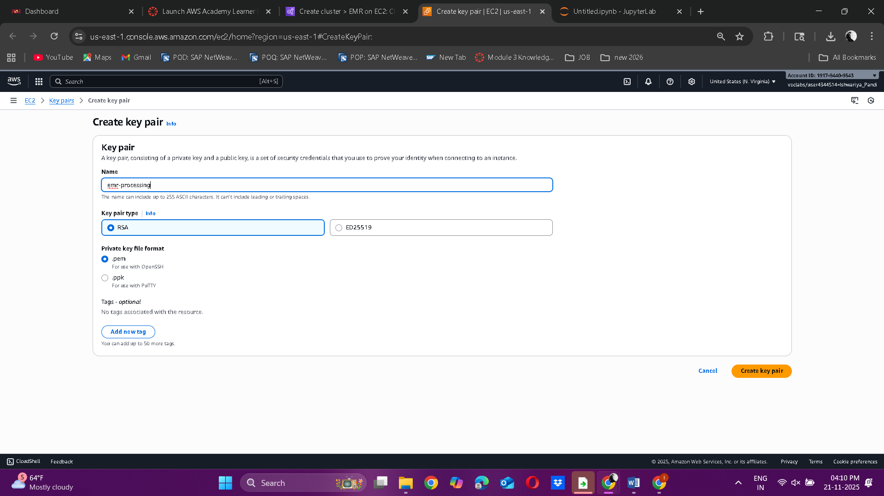  
  
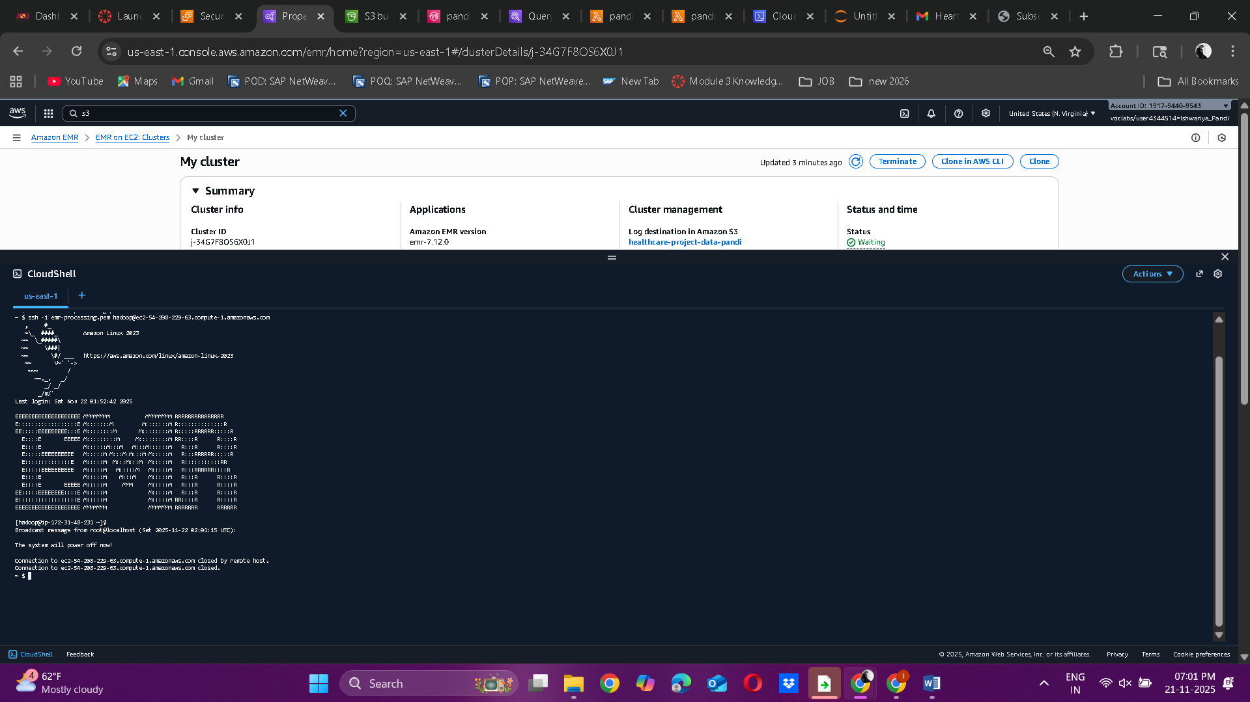  
  
  
  
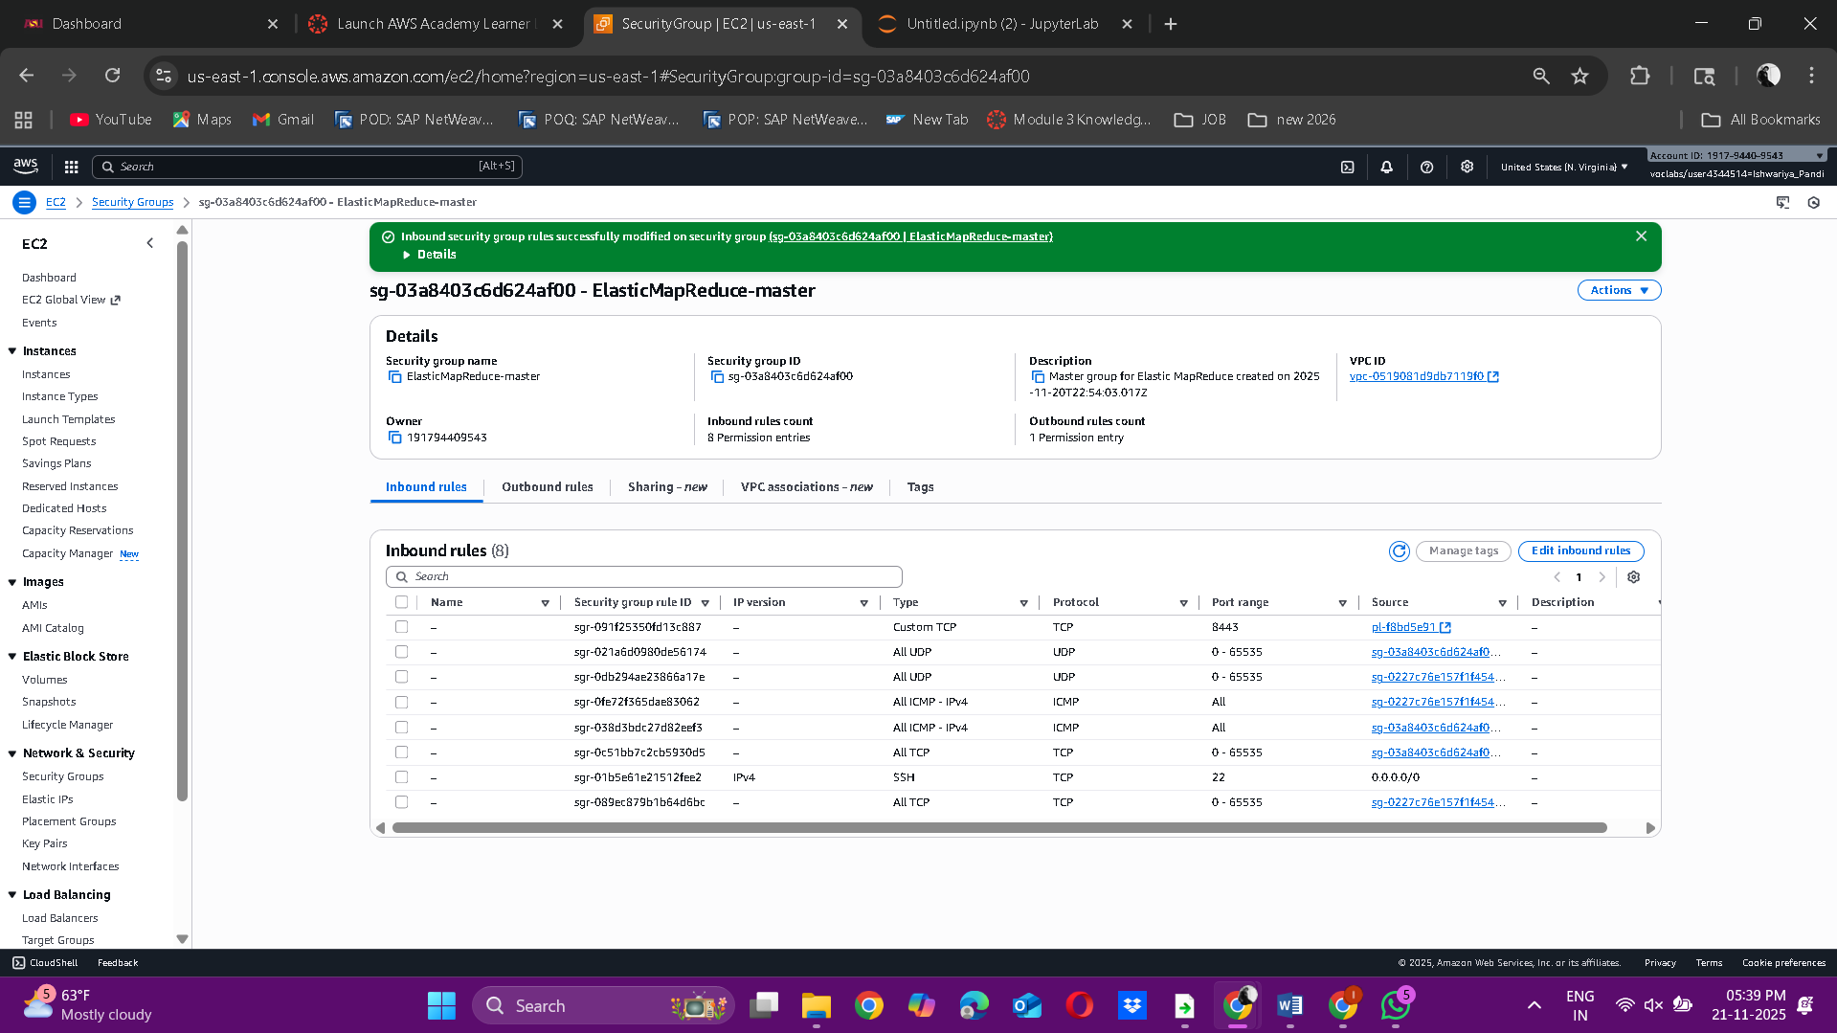  
  
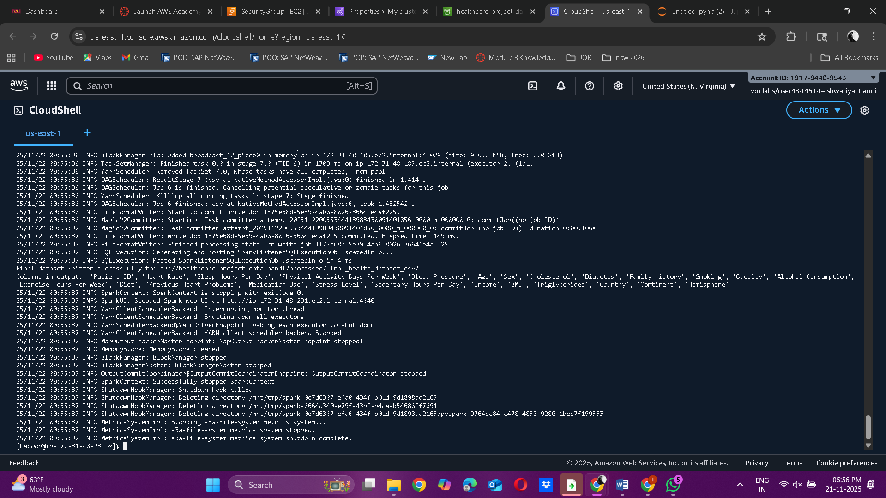  
  
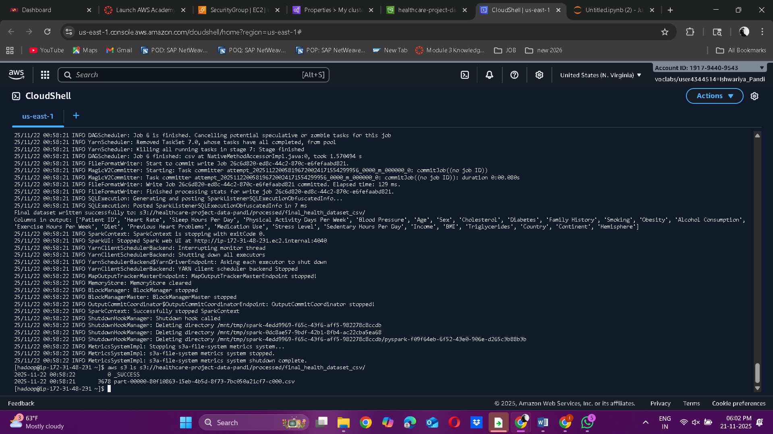

**S3:  Processed data in bucket**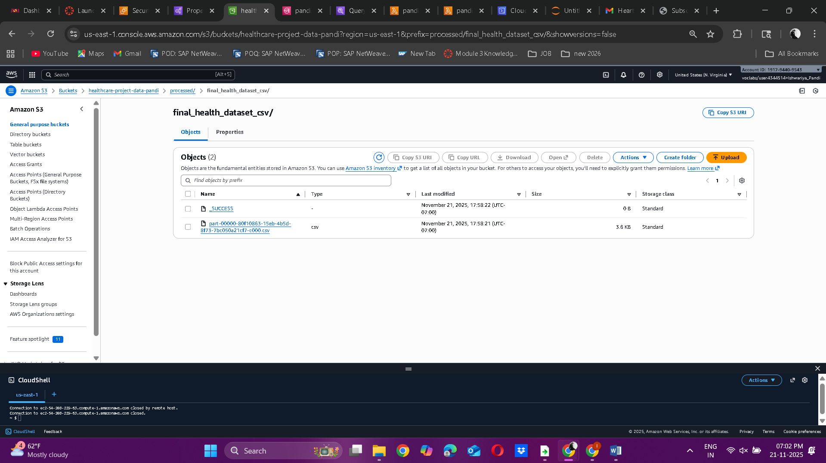

**S4: Model training  Endpoint**  
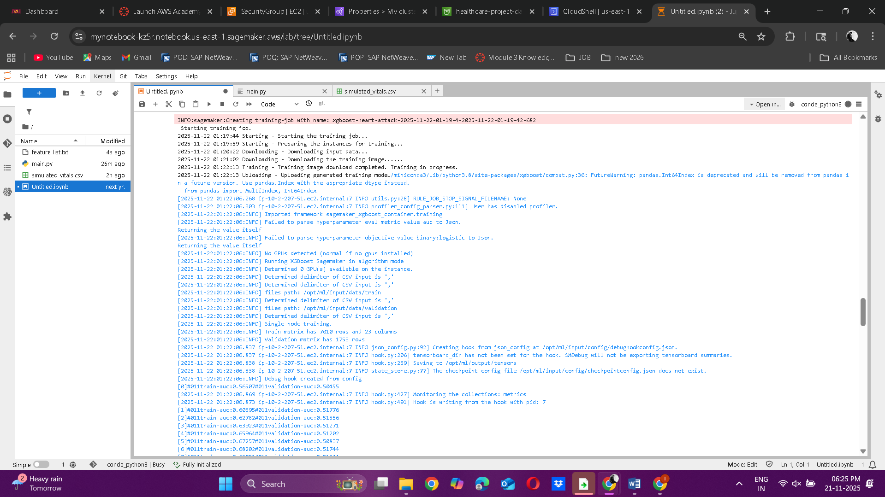  
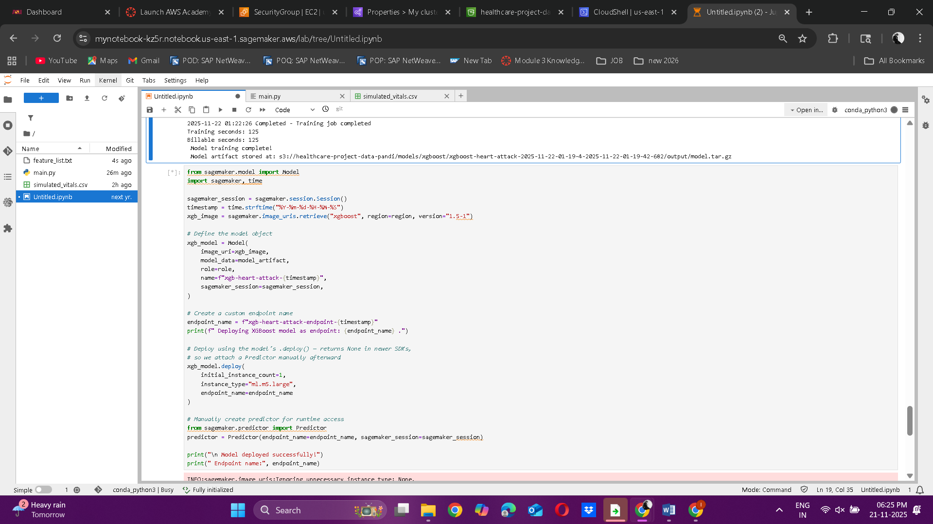  
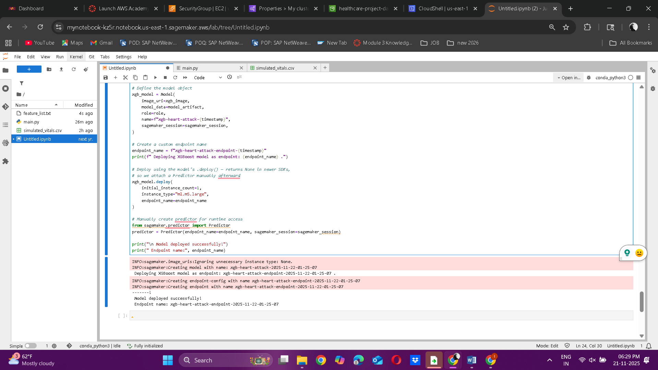  
  
**S5: SNS Alert topic**  
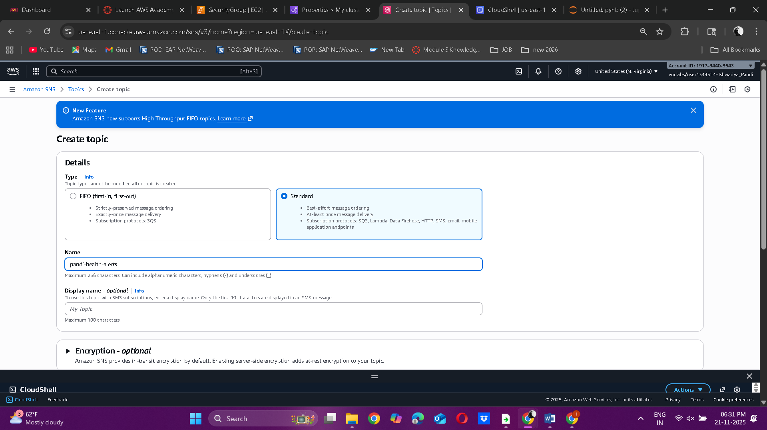  
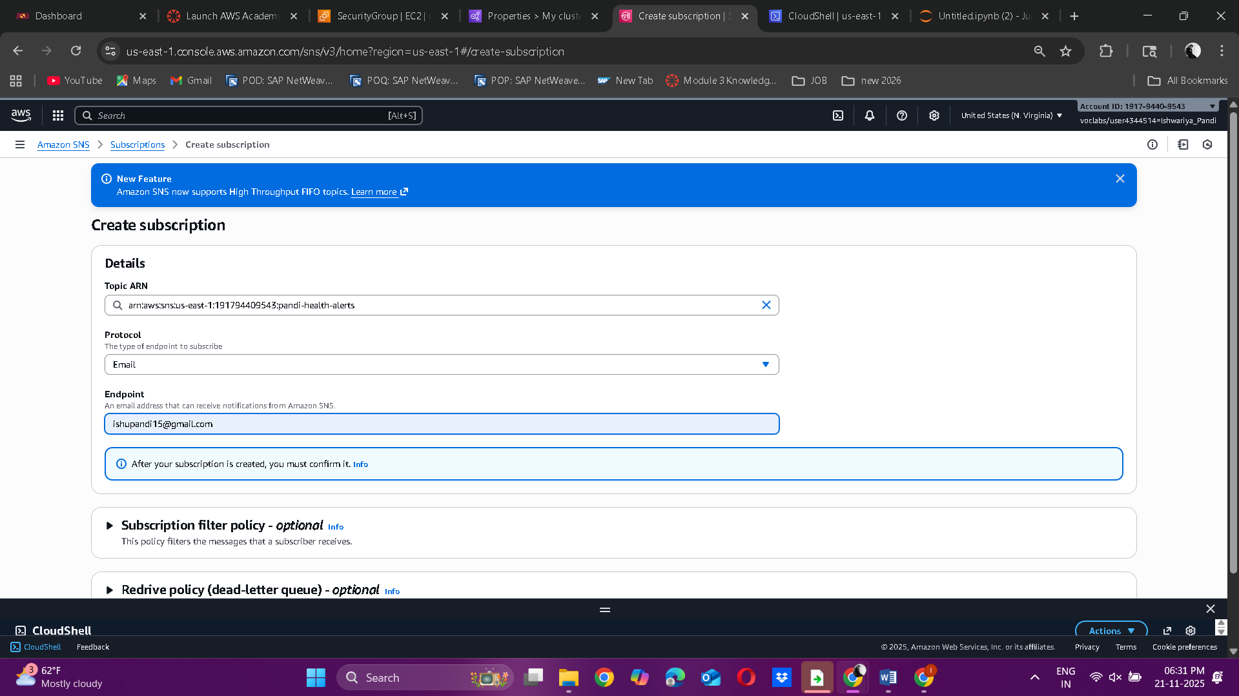  
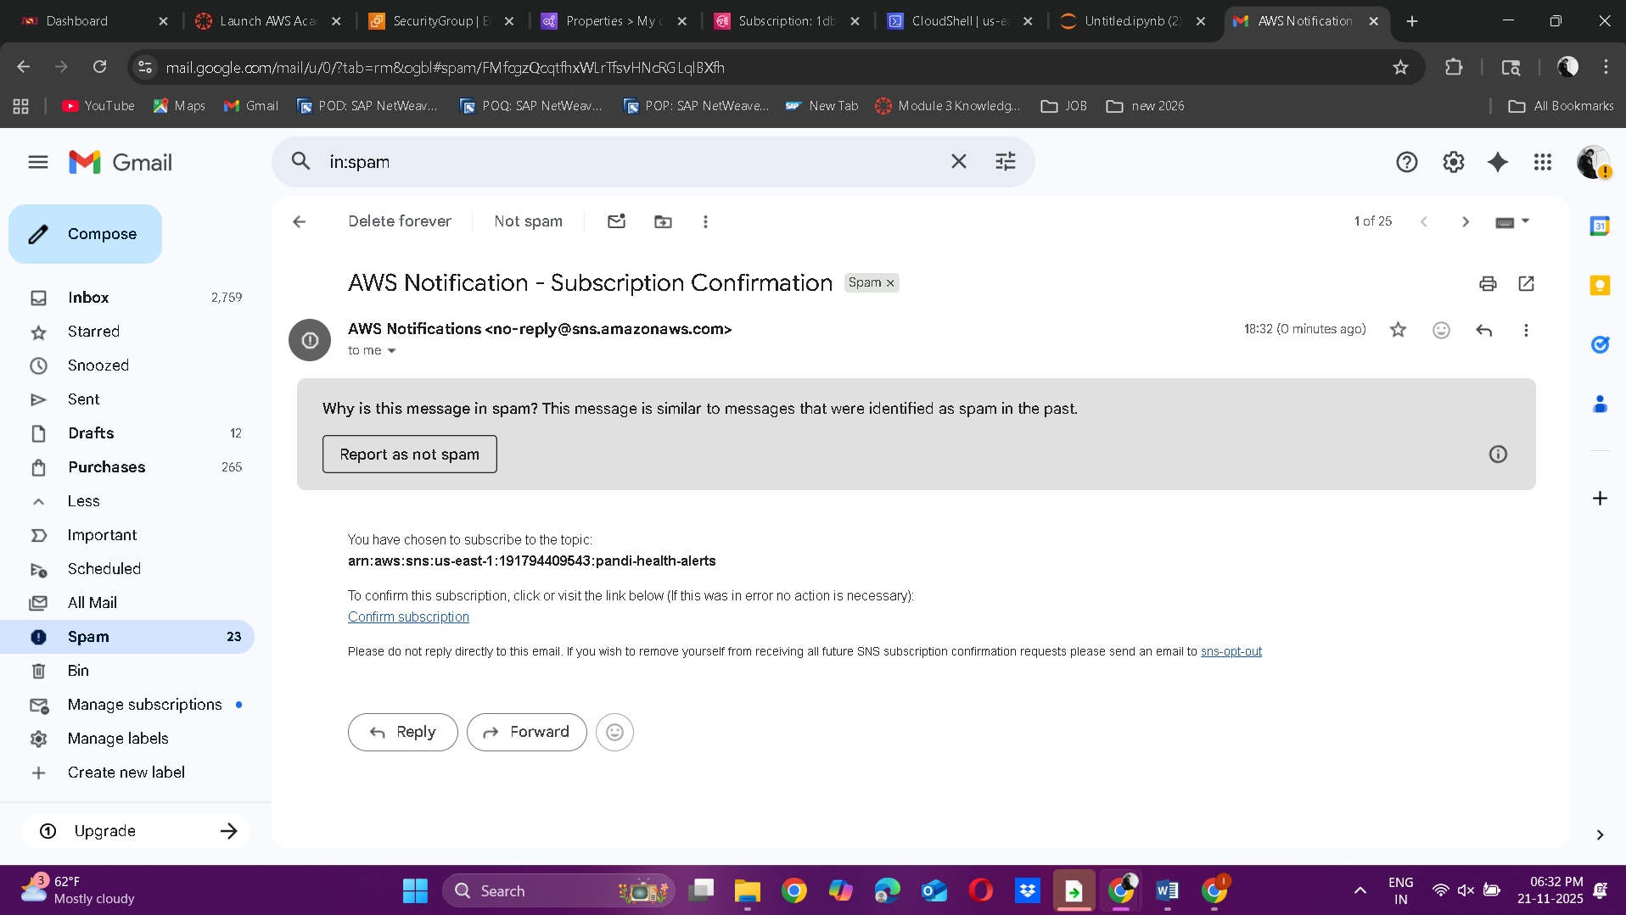  
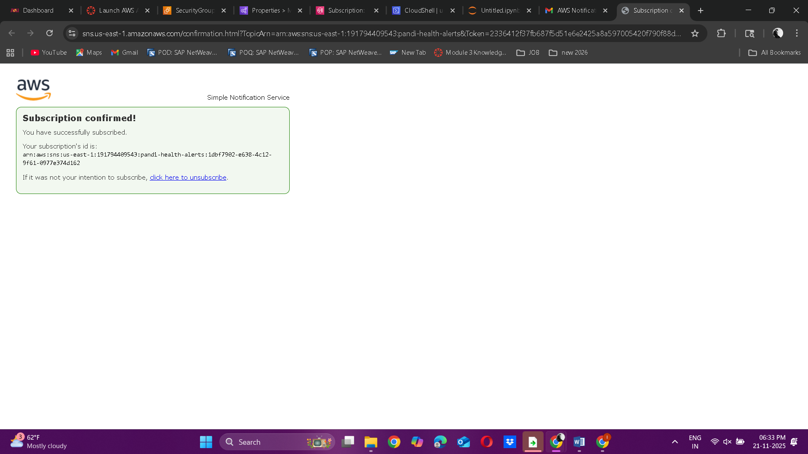  
  
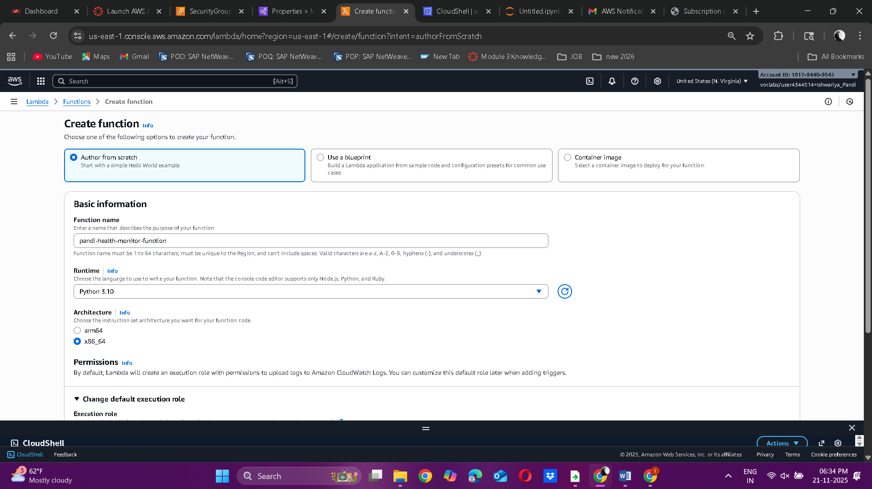  
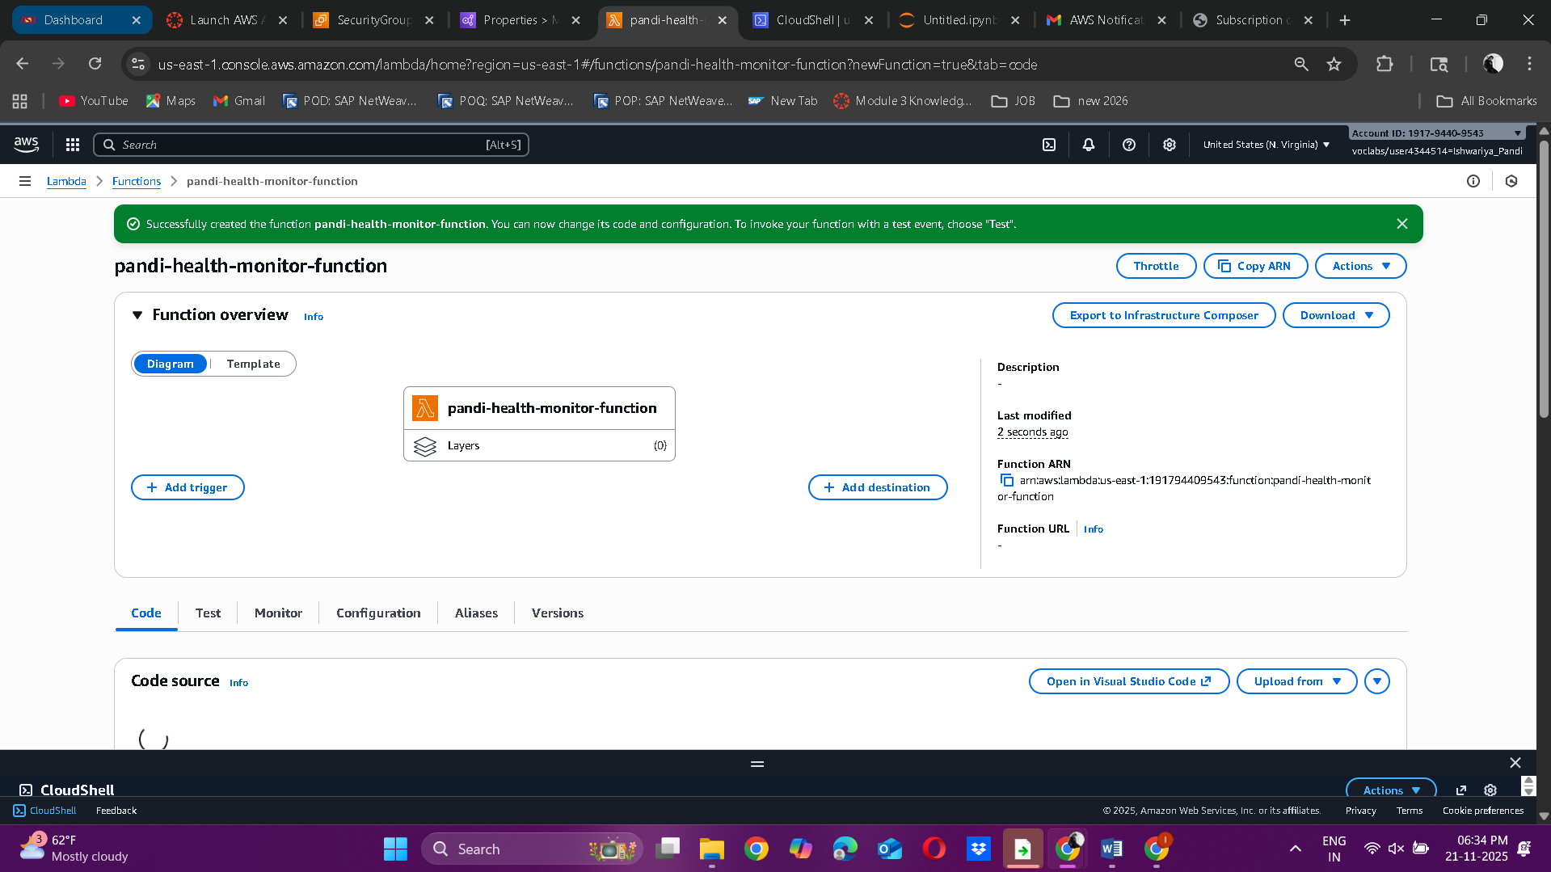  
  
**S6: SNS Email**  
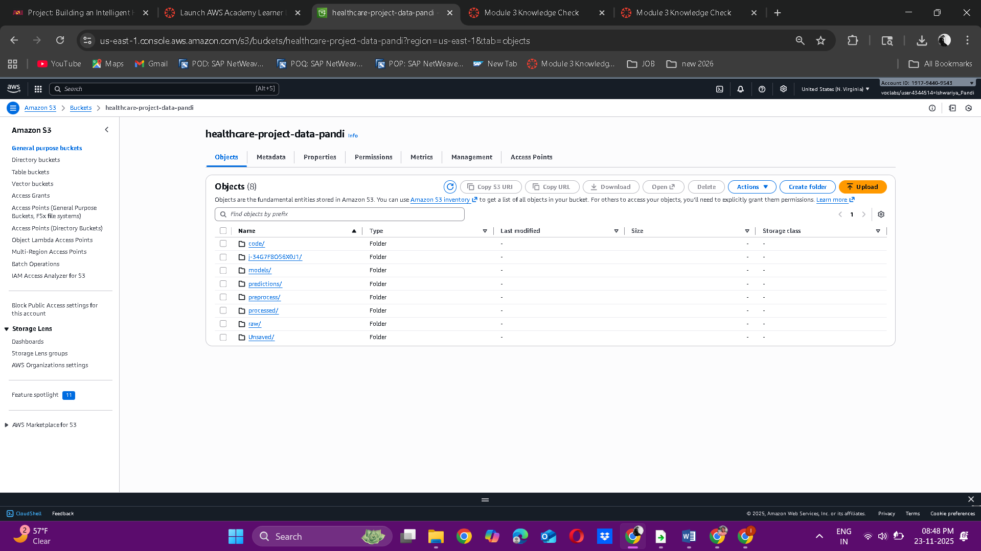  
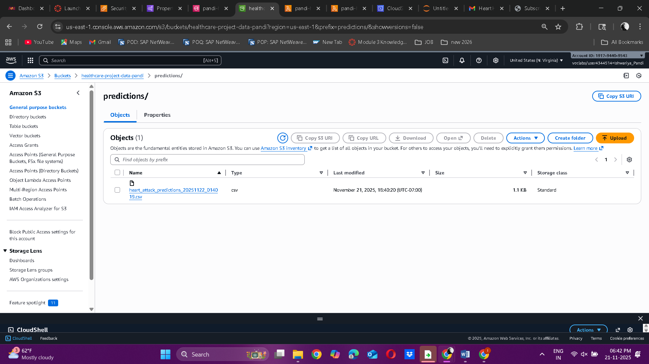  
  
  
**Core Analytics  
S7: Athena query**

**d. Who are the highest-risk patients and what are their other features?**  
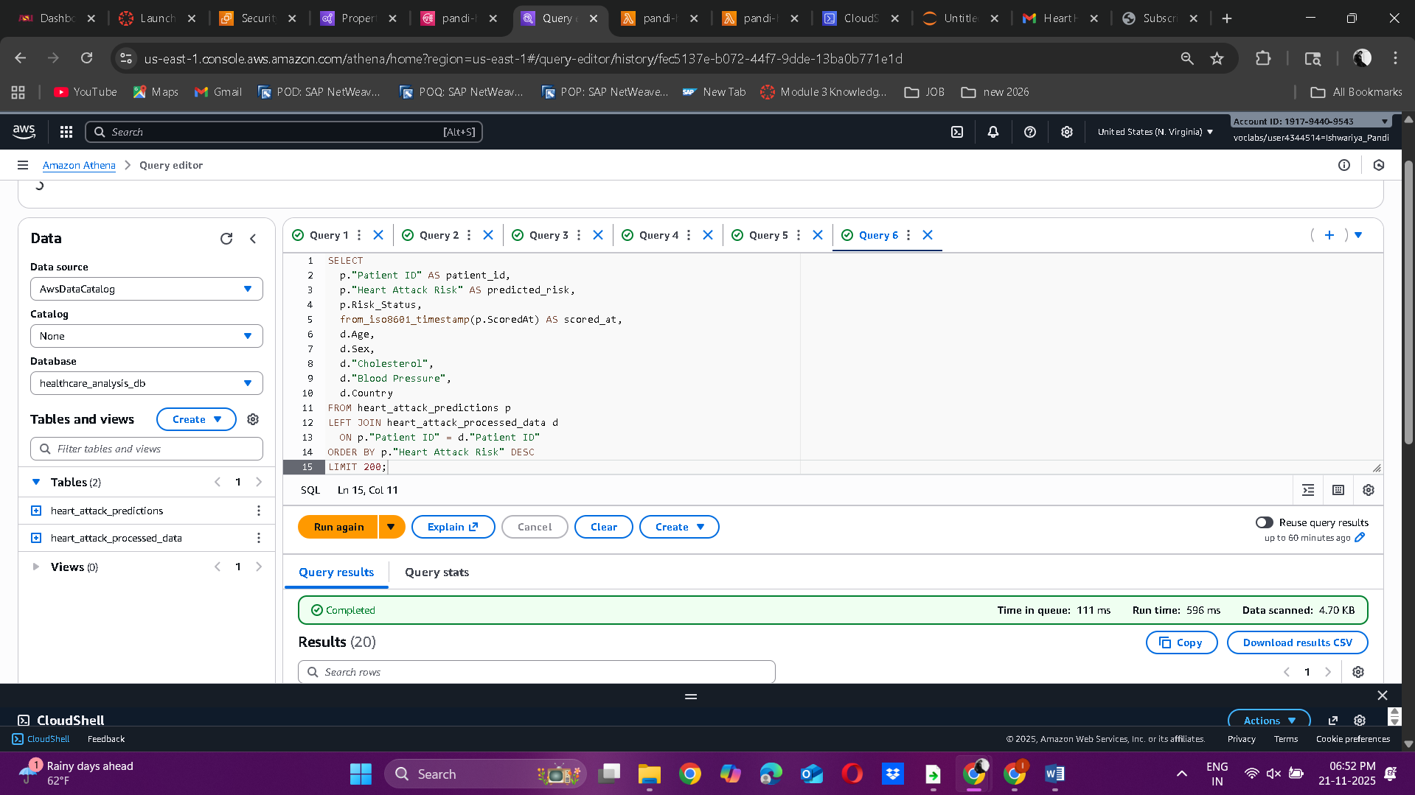  
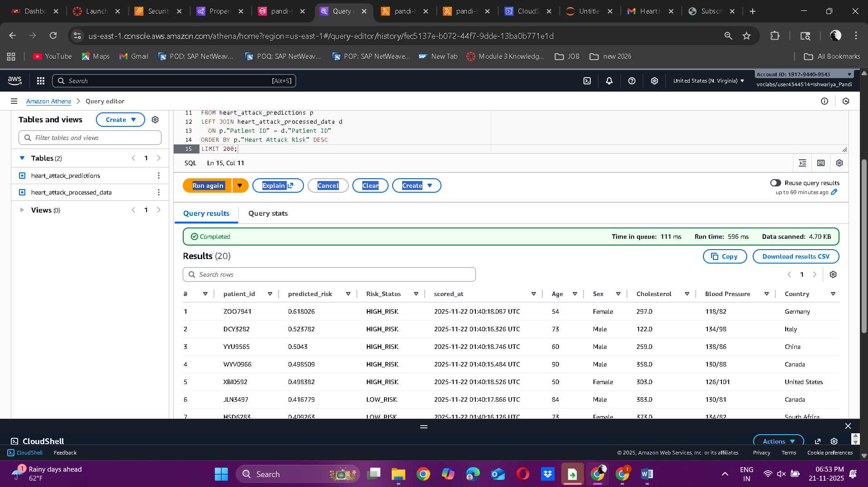  
  
**e. How many patients exceed the alert threshold (> 0.45)?**

The following query counts how many prediction entries have a probability greater than 0.7. It provides a quick estimate of the number of patients who currently exceed the alert threshold and may need urgent medical attention.  
  
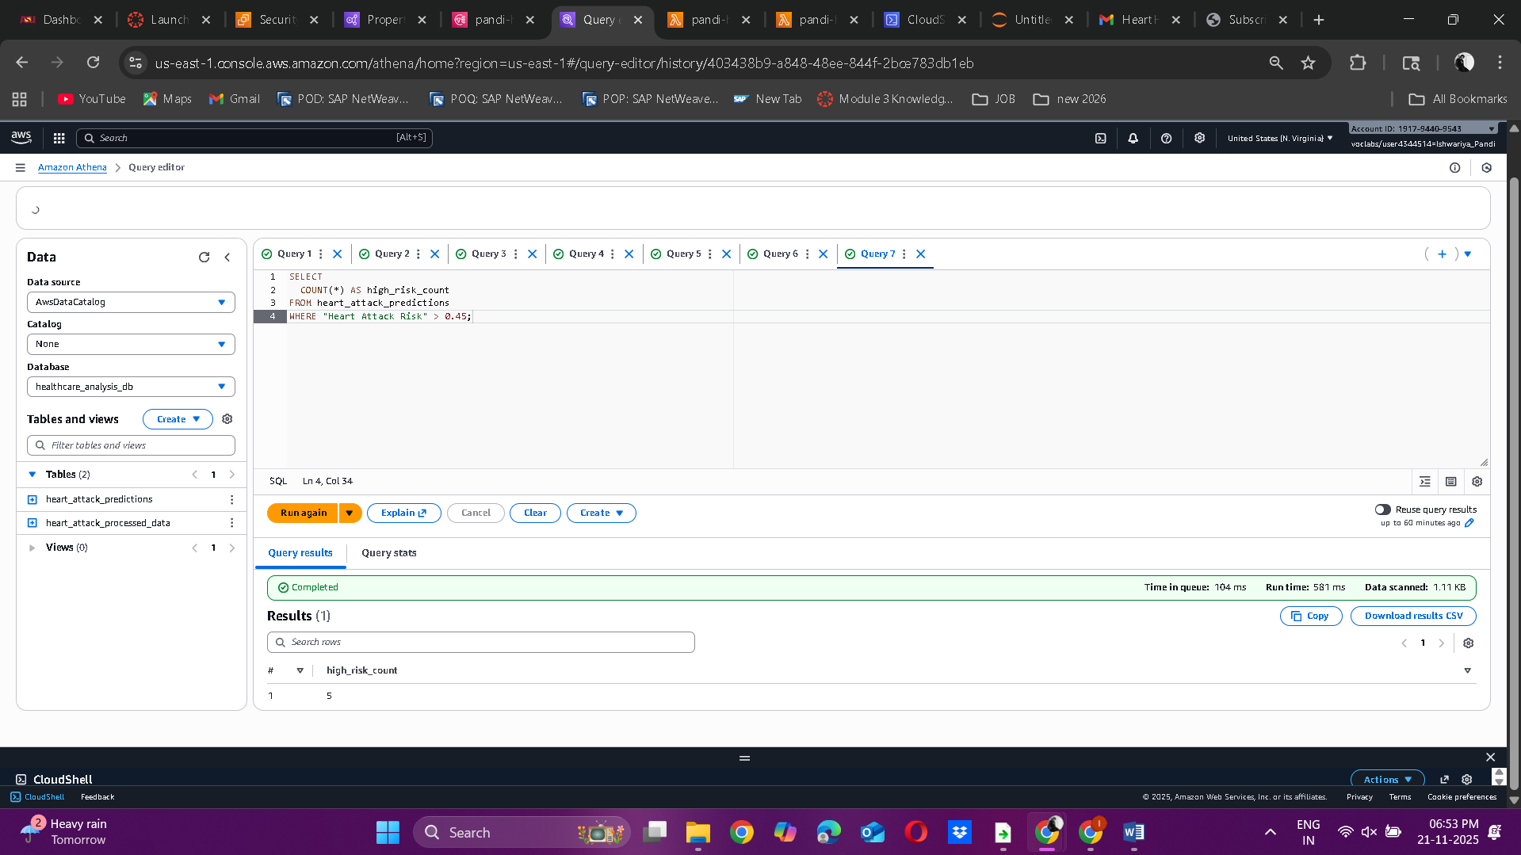  
  
**f. Which age groups have higher average predicted risk?**The following query links the prediction results with the processed vitals data and calculates the average predicted risk for different age groups. It helps identify which age ranges show higher predicted heart attack risk, providing valuable insights for focused screening and health awareness programs.

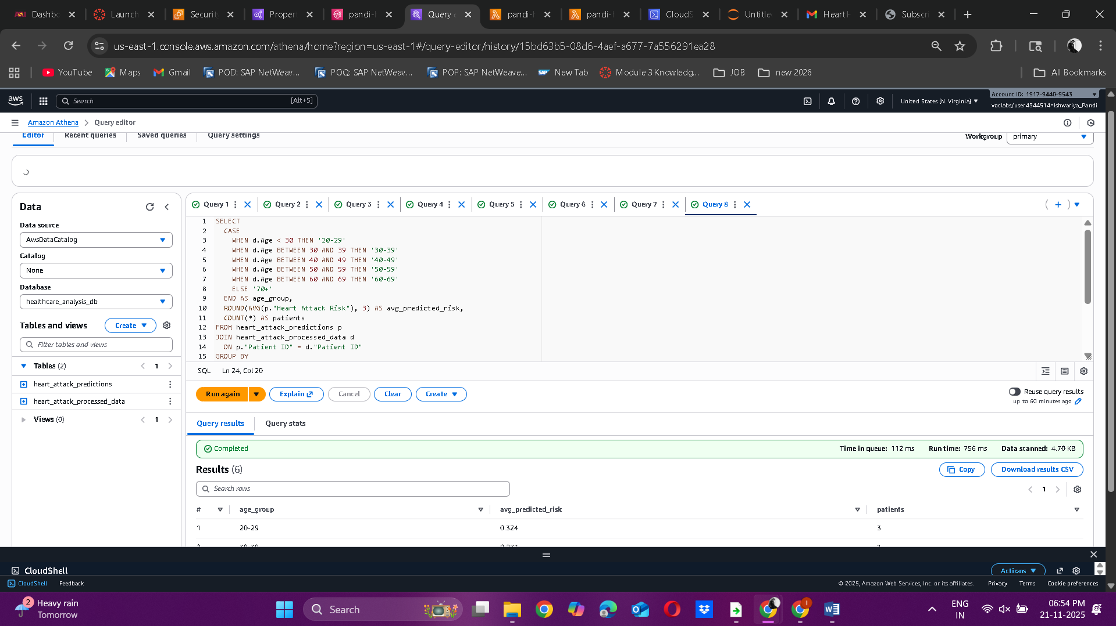  
  
**g. Is shorter sleep associated with higher predicted risk?**The following query groups patients based on their whole-number sleep hours and calculates both the average sleep duration and the average predicted risk for each group. This provides a simple way to explore the relationship between how long patients sleep and their predicted heart attack risk.

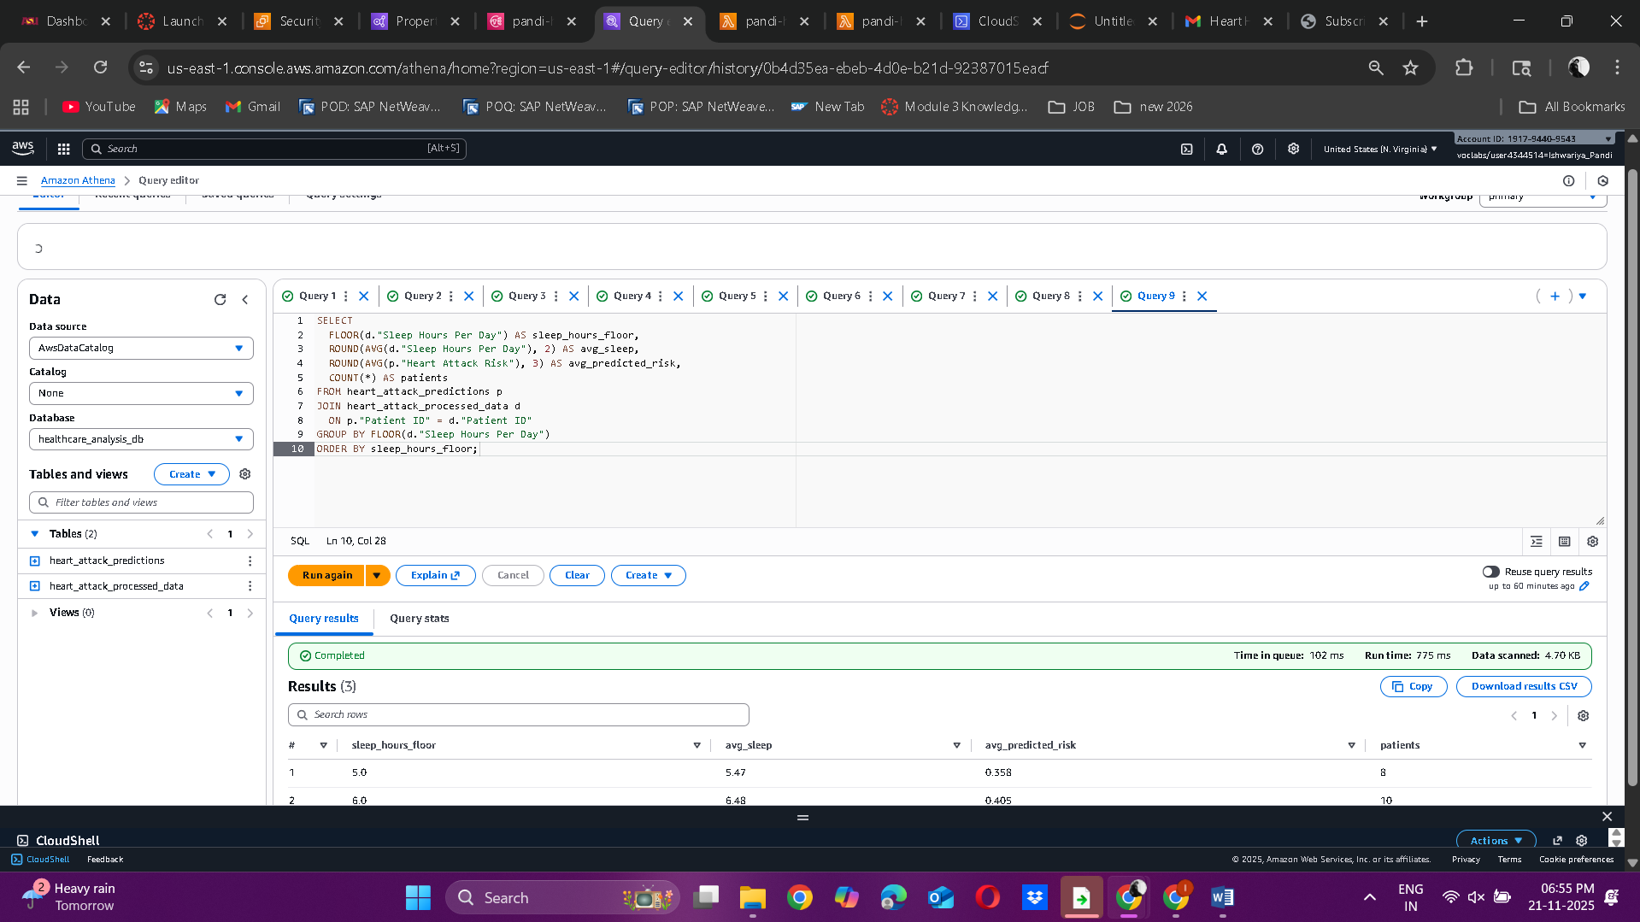

**h. How does physical activity correlate with heart rate and predicted risk?**  
The following query calculates the overall averages of activity days, heart rate, and predicted risk for patients whose records are matched. It serves as a quick check to see if higher physical activity levels are linked to lower heart rates and reduced heart attack risk in the dataset.

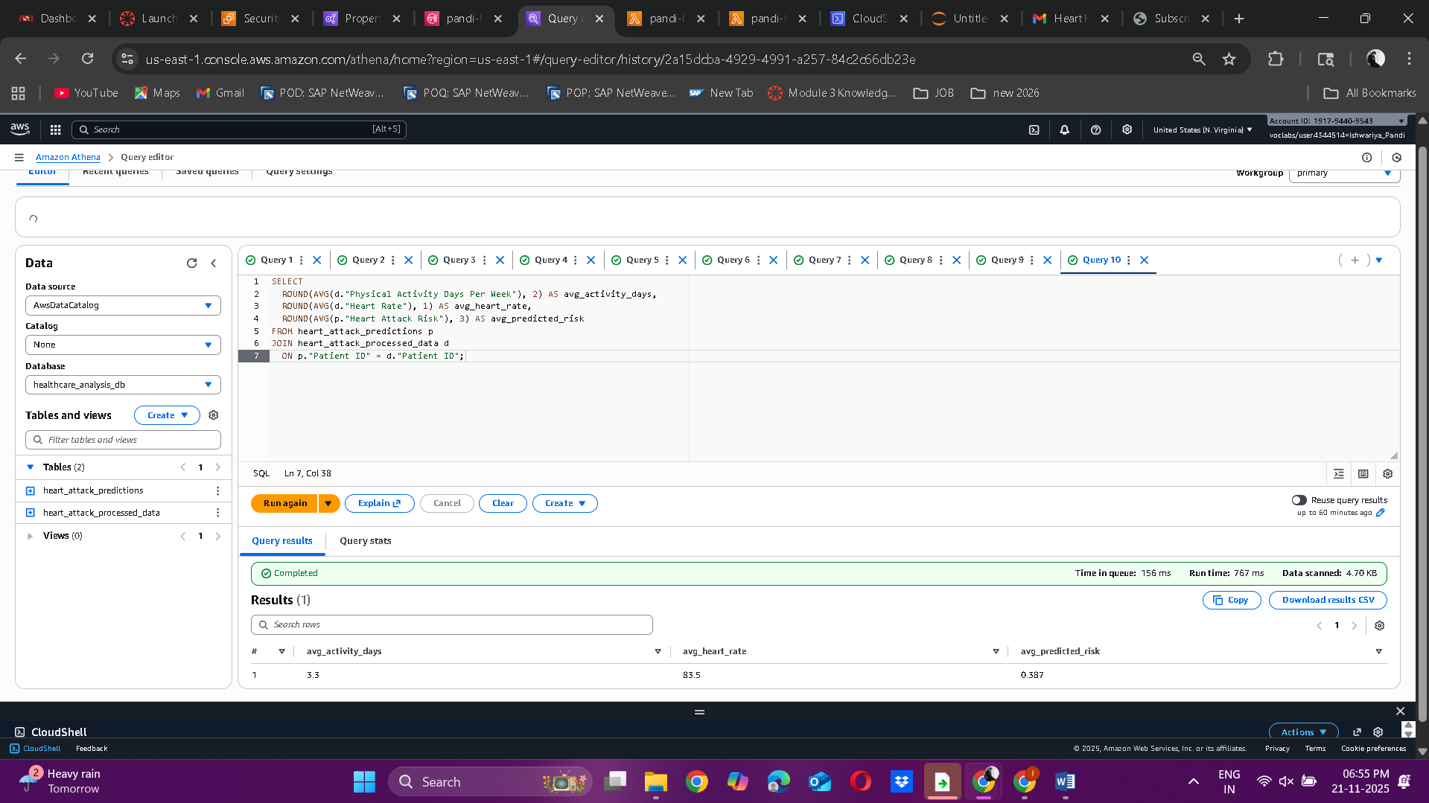

**Phase 1 Script – Simulated Data Generation**

**Q1: What is the main purpose of generating simulated_vitals.csv in Phase 1, and how does this file mimic real patient monitoring data?**

**Answer:** The main purpose of creating **simulated_vitals.csv** in **Phase 1** is to generate realistic daily health readings that act like data collected from wearable devices or hospital monitoring systems. Since real patient data is not available, this phase creates artificial but medically reasonable values for each patient such as heart rate, blood pressure, sleep hours, and physical activity for seven days.

This seven day format mirrors how real devices like Fitbits, smartwatches, or bedside monitors collect information. By keeping all values within normal human ranges, the file provides lifelike input data so that later stages such as EMR data processing, model training, and alert generation can work as if they were using real patient data in a healthcare environment.

**Q2: Why does the script assign random but realistic ranges for heart rate, blood pressure, and sleep hours?**

**Answer:** To make sure the simulated data looks like real human health readings, the script uses random values within realistic medical ranges for heart rate, blood pressure, and sleep hours. By choosing normal systolic and diastolic blood pressure values, healthy heart rate levels, and typical sleep durations, the data closely matches what wearable sensors or hospital monitors would record.

These realistic ranges help prevent the model from learning false patterns and allow later phases to process the data as if it came from real patients. The random variation from day to day makes the data look natural, while the realistic limits ensure that all values stay within valid medical ranges. This approach creates a lifelike dataset without using any real patient information or violating privacy.

**Q3: How many days of vitals are simulated per patient, and why is this important for calculating weekly averages in Phase 2?**

**Answer:** In **Phase 1**, the system creates seven days of vital sign readings for each patient, representing a full week of health data. This is important because **Phase 2** uses EMR Spark to calculate weekly averages such as heart rate, blood pressure, sleep hours, and total days of physical activity. Having data for all seven days ensures that these weekly averages are complete and accurate.

If any days were missing, the weekly results would not truly reflect the patient’s normal condition. By simulating a full week, the data provides a consistent picture of each patient’s typical health patterns, allowing the machine learning model in later phases to make more reliable and realistic predictions.

**Phase 2 Script – Data Processing with AWS EMR (Spark)**

**Q4. Describe how the Spark script aggregates the seven-day vitals for each Patient ID.**

**Answer:** In this step, the Spark script groups all seven days of records for each patient using **groupBy("Patient ID")**. It then calculates weekly summary values for every patient. Spark finds the average heart rate, the average systolic and diastolic blood pressure, the average sleep hours, and counts how many days the patient was physically active.

These calculations use Spark functions such as **avg()**, **round()**, and **sum()** to create clean and organized data. As a result, each patient ends up with one complete set of weekly vital statistics instead of seven separate daily records. This weekly summary is then merged with the historical demographic data and used for model training in the next phases.

**Q5. The historical dataset (heart_attack_prediction_dataset.csv) contains many more IDs than the simulated file.**

**Answer:** The Spark script uses a **left join** to combine the summarized simulated vitals with the historical heart attack dataset. This type of join keeps all the patients from the simulated_vitals.csv file and attaches their matching demographic details from the historical dataset.

Since the simulated file contains only 20 patient IDs, the left join makes sure that the final dataset also includes only those same 20 patients. Any IDs that appear only in the historical file are not included because they do not have simulated vital data and are not needed for weekly risk scoring.

In the end, the final merged dataset includes just the simulated patients who have both their weekly vitals and demographic information, making it ready for accurate model training.

**What join strategy (left, right, inner) is used, and how does it determine which patients appear in the final dataset?**

**Answer:** When the historical dataset is combined with the simulated vitals, the Spark script performs a **left join**. This join keeps all the patient records from the simulated_vitals.csv file and attaches only the matching demographic details from the historical dataset. Any patients who exist only in the historical file are removed because they do not have simulated data.

By giving priority to the simulated vitals table, the left join ensures that those 20 simulated patients always appear in the final merged dataset. This makes the output focused only on patients who have both simulated health data and historical demographic information.

**Q6. Explain how the combined “Blood Pressure” column is created and why it must later be split again in Phase 3.**

**Answer:** The Spark script creates the **“Blood Pressure”** column by joining the average systolic and diastolic values into one string written as **“systolic/diastolic.”** This step happens after the script calculates the average readings for each patient during the aggregation process.

Although this format looks familiar in medical records and is easy to read, it is not suitable for machine learning models. In **Phase 3**, SageMaker needs systolic and diastolic pressure as separate numeric columns to use them as input features. Therefore, during data preprocessing, this combined string is split back into two numeric columns. This ensures that the **XGBoost model** receives clean, numerical data for accurate training.

**Q7. Why are we dropping – old vitals and risk column**

**Answer:** After aggregation and preprocessing, the old vital columns and the existing **“Heart Attack Risk”** column are removed because they are no longer needed. The detailed daily vitals are already summarized into weekly averages by the EMR Spark job, so keeping them would only add extra noise to the model.

Similarly, the **“Heart Attack Risk”** column from the historical dataset must be deleted because the model is supposed to predict this value, not use it as an input. If this column stayed in the data, it would give away the correct answer and make the model learn incorrectly.

By removing these unnecessary columns, the dataset stays clean and contains only the useful features needed for accurate and fair model training.

**Phase 3 Script – Model Training & Deployment (SageMaker)**

**Q8. During preprocessing, what steps are performed to make the data compatible with XGBoost training?**

**Answer:** During preprocessing, several steps are followed to clean and prepare the data so the **XGBoost** model can use it correctly. First, the combined **“Blood Pressure”** column is split into two separate numeric columns for systolic and diastolic values. Next, non-predictive identifiers such as **Patient ID**, **Country**, **Continent**, and **Hemisphere** are removed because they do not help the model make medical predictions.

Categorical columns like **Sex** and **Diet** are then converted into numeric values using one-hot encoding since XGBoost requires all inputs to be numbers. The data is also checked for missing values, which are replaced with zeros or other suitable defaults to prevent training errors.

Finally, all columns are arranged according to the **feature list** to keep their order consistent. These steps make sure the dataset is completely numeric, properly organized, and ready for accurate model training.

**Q9.What is saved in feature_list.txt, and how is this file later used by Lambda in Phase 4?**

**Answer:** The file **feature_list.txt** contains the exact list and order of all input features used to train the XGBoost model in SageMaker. This list includes every numeric and one-hot encoded column that the model expects when making predictions.

In **Phase 4**, the **Lambda function** reads this file from S3 to ensure that each new patient record is processed and arranged in the same column order as the training data. This prevents mismatches between training and prediction stages that could cause wrong results or errors.

By using **feature_list.txt**, Lambda aligns the live input data with the model’s expected format, allowing the system to produce accurate and reliable risk scores.

**Q10.What metric (AUC) is used to evaluate the XGBoost model, and what does it indicate about model performance?**

**Answer:** The **AUC (Area Under the ROC Curve)** is a metric used to measure how well the XGBoost model can tell the difference between high-risk and low-risk patients. It shows the chance that the model will rank a true high-risk patient higher than a true low-risk patient.

An **AUC value close to 1.0** means the model performs very well and can correctly separate risky patients from healthy ones. An **AUC around 0.5** means the model is no better than random guessing.

Therefore, AUC is a clear and reliable way to evaluate how accurately the model can classify patients based on their heart attack risk.

**Q11. How does the endpoint_name generated in Phase 3 link directly to the inference step in the Lambda script?**

**Answer:** When the trained **XGBoost model** is deployed as a real-time endpoint in **Phase 3**, SageMaker gives it a unique **endpoint name**. This name identifies the exact model instance running on SageMaker.

In **Phase 4**, the **Lambda function** uses this same endpoint name inside the invoke_endpoint() call to send the processed patient data directly to the deployed model. Because the endpoint name is written into the Lambda code, it creates a direct link between the Lambda function and the trained model.

This connection allows Lambda to request predictions and get heart-attack risk scores instantly. Without the correct endpoint name, Lambda would not know which model to contact, and real-time predictions would not work.

**Integration & Reflection**

**Q12. How do Phases 1 – 4 together represent a complete data-driven pipeline from data generation to real-time clinical alerts?**

**Answer:** Phases 1 to 4 turn raw simulated health data into real time clinical alerts, forming a complete data driven healthcare system.

In Phase 1, artificial patient vitals are created to imitate daily readings from wearable devices.  
Phase 2 uses EMR and Spark to process this information on a large scale, producing weekly averages that summarize each patient’s overall health.  
In Phase 3, the cleaned dataset is used in SageMaker to train an XGBoost model and deploy a real time endpoint that predicts heart attack risk.  
Finally, Phase 4 uses a Lambda function to automate continuous monitoring. It collects the newest patient data, prepares it, sends it to the SageMaker endpoint for prediction, and triggers SNS alerts for patients marked as high risk.

Together, these four phases represent the full workflow of a clinical monitoring system, from generating and processing data to machine learning prediction and real time alerting.

**Q13. If model performance degrades over time, which phases would need to be revisited or retrained, and why?**

###### **Answer:** If the model’s accuracy decreases over time, Phases 1, 2, and 3 should be updated or retrained. Phase 1 may need revision if real patient vital signs or health patterns change, since the simulated data would no longer represent current conditions accurately. Phase 2 might require updates to its preprocessing, aggregation, or feature engineering methods to include new clinical trends or improved data transformations. Phase 3, which handles model training, is the most important to retrain because the machine learning model depends on recent patterns and features in the data. Regular retraining helps the model maintain accurate predictions as new patient behaviors, demographics, or health issues emerge. Phase 4 generally does not need changes because the Lambda function only automates predictions using the latest model and will automatically work with any newly deployed version after retraining.

**Q14: In the current setup of the Heart Health Alert project, will alerts be generated only for the 20 simulated ids, if tour answer is "yes" then explain" why" ?**

**Answer:** Yes, only the 20 simulated patient IDs will receive alerts in the current setup. This happens because the entire pipeline is built on the simulated_vitals.csv file, which contains data for exactly 20 patients. In Phase 2, the EMR Spark process aggregates vitals only for these 20 IDs, and the left join ensures that no other patients are included in the final processed dataset. When Phase 4 runs, the Lambda function reads only the records in the processed folder and sends them to the model for scoring. As a result, alerts through SNS are generated only for these 20 patients, since no other patient data exists in the system. To expand alerting beyond this sample, new patient vitals would need to be added and processed through the same pipeline.  
  
**d. all phases code text code text.**

**Phase 1 . Prepare Input Data**

**Phase 1:Code for generating the csv**

# Cell 1 — generate simulated vitals

import pandas as pd

import random

import time

from datetime import datetime

patient_ids = [

"BMW7812","CZE1114","BNI9906","JLN3497","GFO8847","ZOO7941",

"WYV0966","XXM0972","XCQ5937","FTJ5456","HSD6283","YSP0073",

"FPS0415","YYU9565","VTW9069","DCY3282","DXB2434","COP0566",

"XBI0592","RQX1211"

]

records = []

now_ts = int(time.time())

for pid in patient_ids:

for i in range(7): # 7 days per patient

record = {

"Patient ID": pid,

"Heart Rate": random.randint(60, 110),

"BP_Systolic": random.randint(100, 170),

"BP_Diastolic": random.randint(60, 120),

"Sleep Hours Per Day": round(random.uniform(3, 9), 1),

"Physical Activity Per day": random.randint(0, 1),

# Timestamp as ISO string (human friendly) and epoch for downstream processing

"Timestamp_epoch": now_ts + i,

"Timestamp_iso": datetime.utcfromtimestamp(now_ts + i).isoformat()

}

records.append(record)

df = pd.DataFrame(records)

csv_filename = "simulated_vitals.csv"

df.to_csv(csv_filename, index=False)

print(f"Saved {csv_filename} with {len(df)} rows in notebook working directory.")

df.head(8)  
  
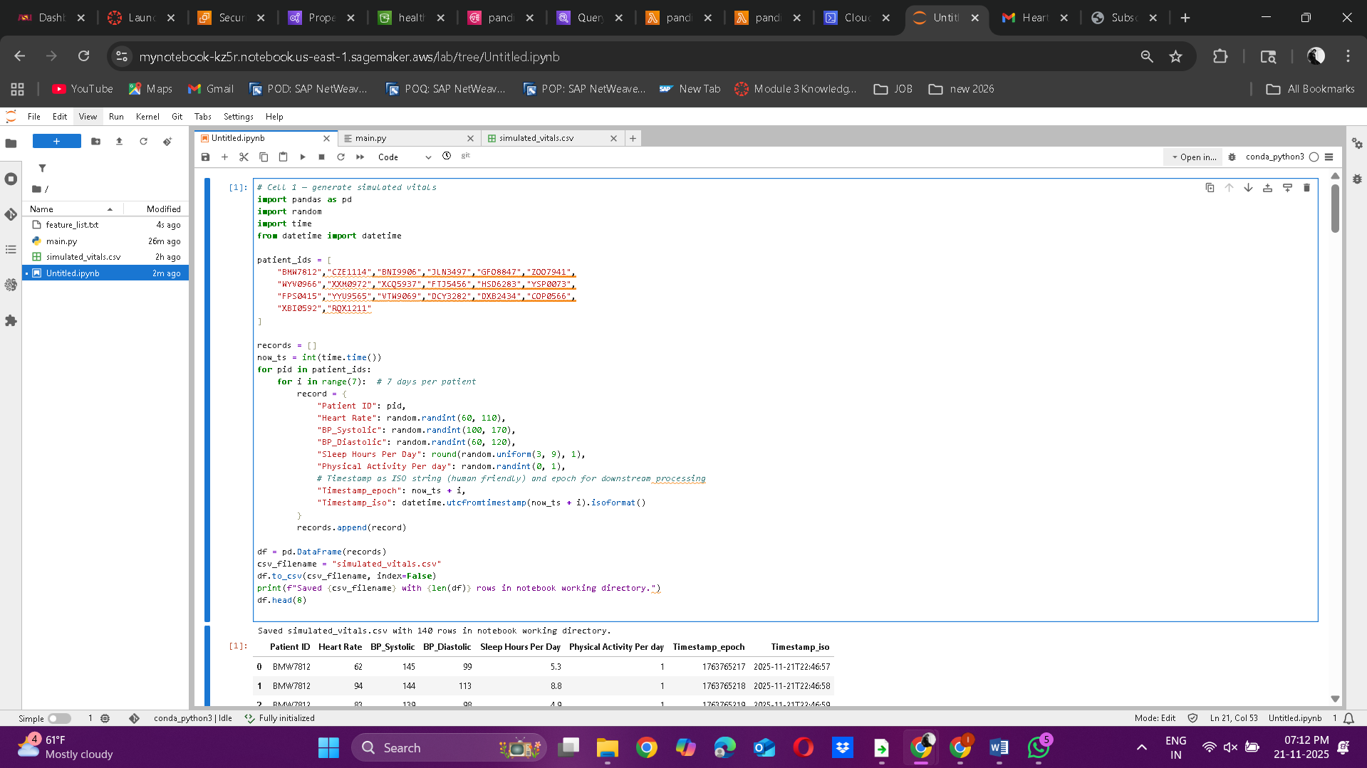  
  
**Phase 2: Process Data Using AWS EMR (Spark)**

**The main.py for Spark**  
from pyspark.sql import SparkSession

from pyspark.sql.functions import avg, sum as _sum, round as _round, col, concat_ws

from pyspark.sql.types import IntegerType

# CONFIG

HIST_PATH = "s3://healthcare-project-data-pandi/raw/historical/heart_attack_prediction_dataset.csv"

SIM_PATH = "s3://healthcare-project-data-pandi/raw/simulated/simulated_vitals.csv"

OUT_PATH = "s3://healthcare-project-data-pandi/processed/final_health_dataset_csv/"

# Start Spark session

spark = SparkSession.builder.appName("AggregateVitalsJoinFinal").getOrCreate()

# Load datasets

hist = spark.read.option("header", True).csv(HIST_PATH, inferSchema=True)

sim = spark.read.option("header", True).csv(SIM_PATH, inferSchema=True)

# Aggregate simulated vitals (7 days → weekly averages)

agg = sim.groupBy("Patient ID").agg(

_round(avg(col("Heart Rate")), 0).alias("Heart Rate"),

_round(avg(col("BP_Systolic")), 0).alias("AvgBP_Systolic"),

_round(avg(col("BP_Diastolic")), 0).alias("AvgBP_Diastolic"),

_round(avg(col("Sleep Hours Per Day")), 2).alias("Sleep Hours Per Day"),

_sum(col("Physical Activity Per day")).alias("Physical Activity Days Per Week")

)

# Combine averaged systolic & diastolic into "Blood Pressure"

agg = agg.withColumn(

"Blood Pressure",

concat_ws("/", col("AvgBP_Systolic").cast(IntegerType()), col("AvgBP_Diastolic").cast(IntegerType()))

).drop("AvgBP_Systolic", "AvgBP_Diastolic")

# Clean historical dataset (drop old vitals and risk column)

hist_clean = hist.drop(

"Heart Rate",

"Blood Pressure",

"Sleep Hours Per Day",

"Physical Activity Days Per Week",

"Heart Attack Risk"

)

# Join historical demographics with aggregated vitals

final =agg.join(hist_clean, on="Patient ID", how="left")

# Write final dataset to CSV (ready for SageMaker)

final.coalesce(1).write.mode("overwrite").option("header", True).csv(OUT_PATH)

print("Final dataset written successfully to:", OUT_PATH)

print("Columns in output:", final.columns)

spark.stop()  
  
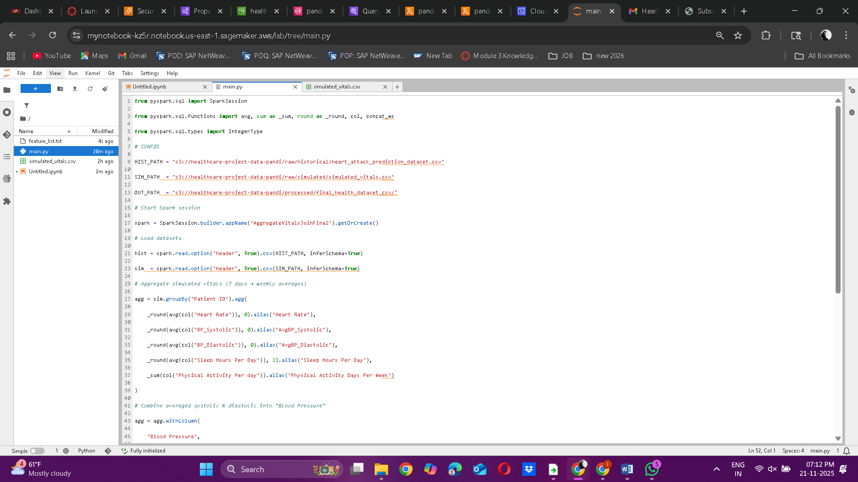  
  
**# Cell 2 — preview and quick checks**

import os

print("File exists:", os.path.exists("simulated_vitals.csv"))

print("Size (bytes):", os.path.getsize("simulated_vitals.csv"))

display(df.describe(include='all').transpose())  
 **# Cell 3 — upload to S3 (change bucket name)**

import boto3

s3 = boto3.client("s3")

bucket = "healthcare-project-data-pandi"

s3_key = "raw/simulated/simulated_vitals.csv" # target path inside the bucket

# Create the folder keys are implicit in S3; just upload the file

try:

s3.upload_file("simulated_vitals.csv", bucket, s3_key)

print("Uploaded to s3://{}/{}".format(bucket, s3_key))

except Exception as e:

print("Upload failed:", e)

# If you see AccessDenied, add S3 PutObject permissions to the notebook role  
import boto3

s3 = boto3.client("s3")

bucket = "healthcare-project-data-pandi"

s3_key = "code/main.py"

s3.upload_file("main.py", bucket, s3_key)

print("Uploaded to s3://{}/{}".format(bucket, s3_key)) **2.4 Run the Spark Job and Verify the Output in S3**

* **Run the PySpark job:bash**

spark-submit main.py > log.txt

* **Check the output:bash**

cat log.txt

**Phase 3 : Train & Deploy Model in Amazon SageMaker**

**Cell 1: Imports & Configuration**  
import boto3, io, pandas as pd

from sklearn.model_selection import train_test_split

import sagemaker

from sagemaker import get_execution_role

region = "us-east-1" # update if needed

bucket = "healthcare-project-data-pandi" # your bucket name

role = get_execution_role()

s3 = boto3.client("s3", region_name=region)

hist_key = "raw/historical/heart_attack_prediction_dataset.csv"

**Cell 2: Load Processed Dataset & Preview**

load the processed/merged CSV from S3 (produced by EMR) to confirm shape & columns.  
obj = s3.get_object(Bucket=bucket, Key=hist_key)

df = pd.read_csv(io.BytesIO(obj["Body"].read()))

print("Loaded dataset:", df.shape)

df.head(2)

**Screenshot 1 & 2:**

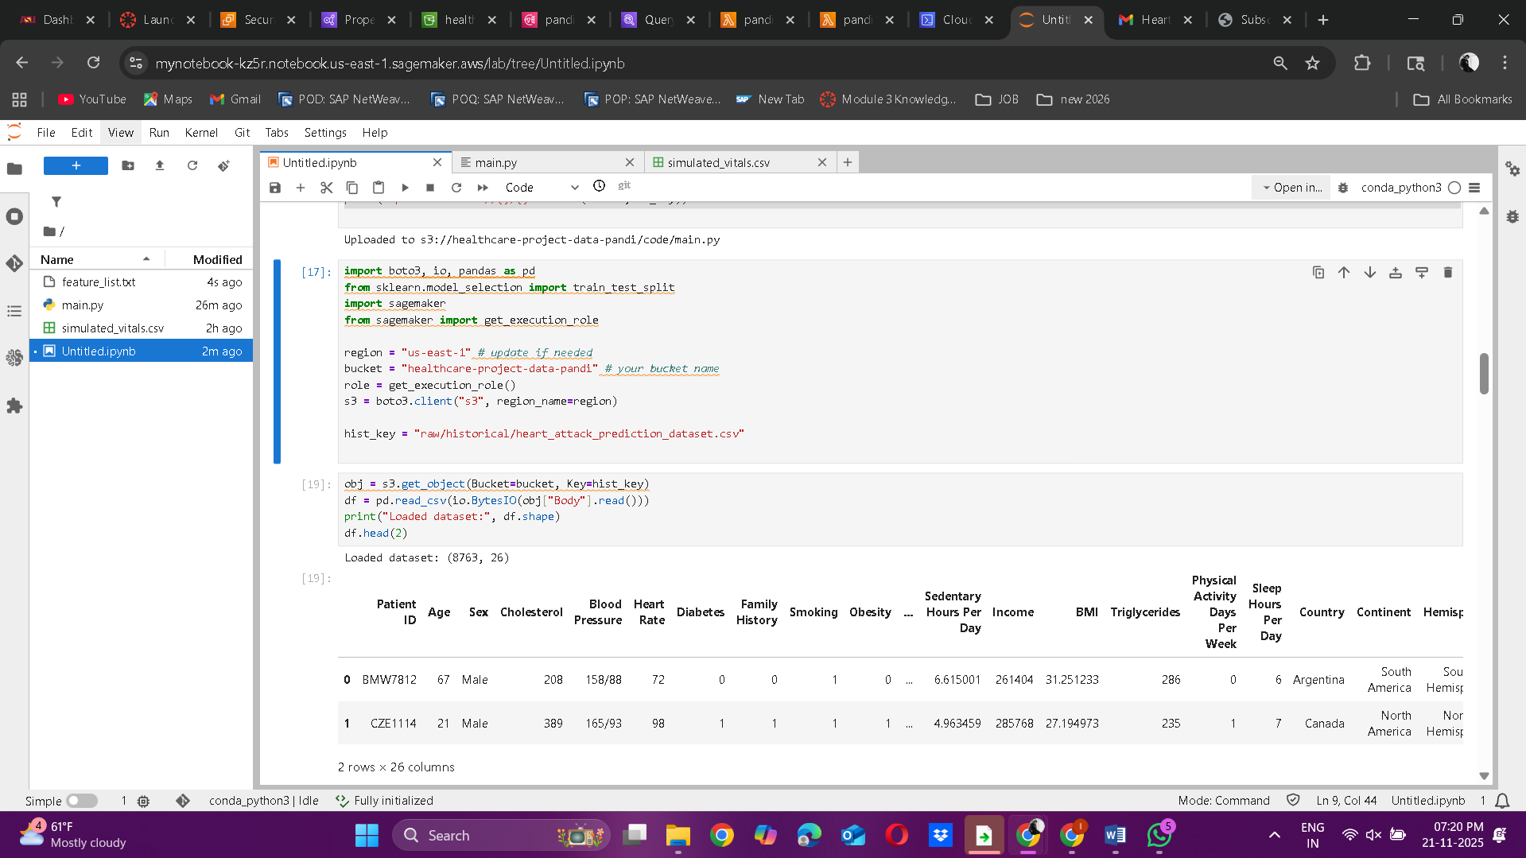

**Preprocess the historical dataset**

**Cell 3: Function to Preprocess the data:**  
def preprocess_health_data(df):

# Split blood pressure

if "Blood Pressure" in df.columns:

bp = df["Blood Pressure"].astype(str).str.split("/", n=1, expand=True)

df["BP_Systolic"] = pd.to_numeric(bp[0], errors="coerce")

df["BP_Diastolic"] = pd.to_numeric(bp[1], errors="coerce")

df.drop(columns=["Blood Pressure"], inplace=True)

# Drop identifiers

df = df.drop(columns=["Patient ID","Country","Continent","Hemisphere"], errors="ignore")

# One-hot encode categoricals

df = pd.get_dummies(df, drop_first=True).fillna(0)

return df  
**Cell 4: Preprocessing and then spliting dataset into train/test**  
  
**Upload the train/test dataset and feature list to S3 before training the dataset**  
proc_df = preprocess_health_data(df)

y = proc_df["Heart Attack Risk"].astype(int)

X = proc_df.drop(columns=["Heart Attack Risk"])

final_df = pd.concat([y, X], axis=1)

train_df, test_df = train_test_split(final_df, test_size=0.2, random_state=42, stratify=y)

print("Train:", train_df.shape, "| Test:", test_df.shape)

print("\n Sample training row:")

display(train_df.head(1))  
**Screenshot 3 & 4:**  
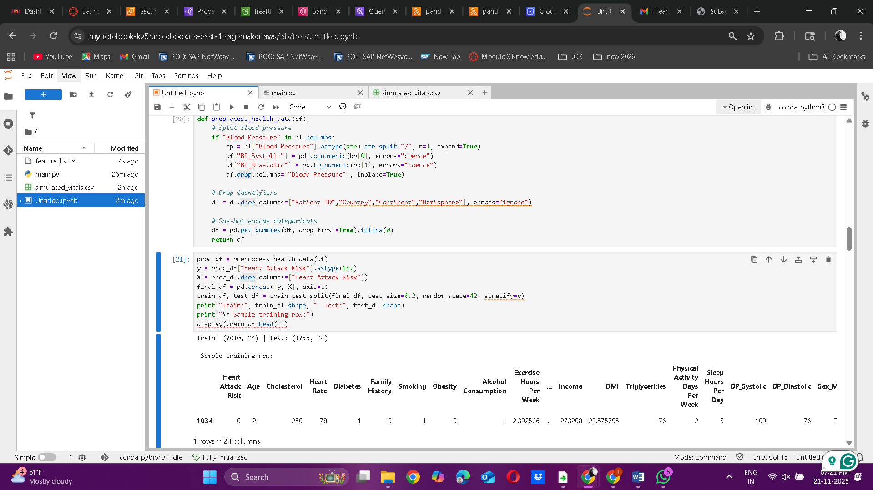

**Cell 5: Upload the train/test dataset into csv:**

train_key = "raw/historical/train/train.csv"

test_key = "raw/historical/test/test.csv"

def upload_csv(df, key):

s3.put_object(Bucket=bucket, Key=key, Body=df.to_csv(index=False, header=False).encode())

print(f"Uploaded → s3://{bucket}/{key}")

upload_csv(train_df, train_key)

upload_csv(test_df, test_key)  
  
  
**Cell 6: Upload feature list to S3 so that this can be used by the simulated Processed data use the trained model  
feature_list = list(X.columns)**

**with open("feature_list.txt", "w") as f:**

**f.write("\n".join(feature_list))**

**!aws s3 cp feature_list.txt s3://{bucket}/preprocess/feature_list.txt**

**print(f" Uploaded feature list → s3://{bucket}/preprocess/feature_list.txt")  
Screenshot 5 & 6:  
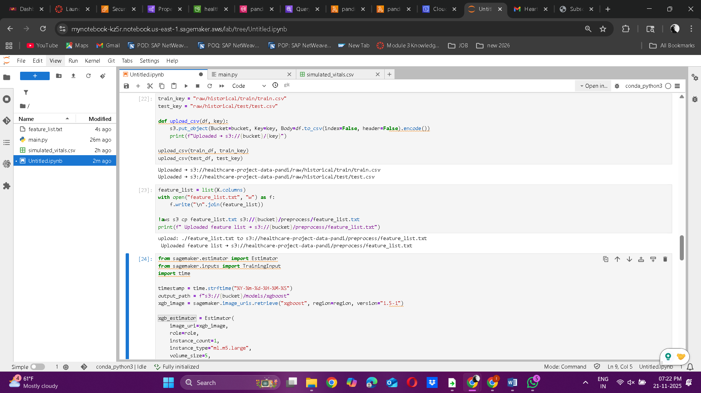  
  
3.2  : Train and deploy the Heart Attack prediction Model**

**Cell 7: Train the model**

from sagemaker.estimator import Estimator

from sagemaker.inputs import TrainingInput

import time

timestamp = time.strftime("%Y-%m-%d-%H-%M-%S")

output_path = f"s3://{bucket}/models/xgboost"

xgb_image = sagemaker.image_uris.retrieve("xgboost", region=region, version="1.5-1")

xgb_estimator = Estimator(

image_uri=xgb_image,

role=role,

instance_count=1,

instance_type="ml.m5.large",

volume_size=5,

output_path=output_path,

base_job_name=f"xgboost-heart-attack-{timestamp}",

)

xgb_estimator.set_hyperparameters(

objective="binary:logistic",

num_round=100,

eta=0.1,

max_depth=5,

subsample=0.8,

colsample_bytree=0.8,

eval_metric="auc"

)

train_input = f"s3://{bucket}/{train_key}"

test_input = f"s3://{bucket}/{test_key}"

print(" Starting training job.")

xgb_estimator.fit(

{

"train": TrainingInput(train_input, content_type="text/csv"),

"validation": TrainingInput(test_input, content_type="text/csv")

}

)

model_artifact = xgb_estimator.model_data

print(" Model training complete!")

print(" Model artifact stored at:", model_artifact)  
  
**Screenshot 7:**  
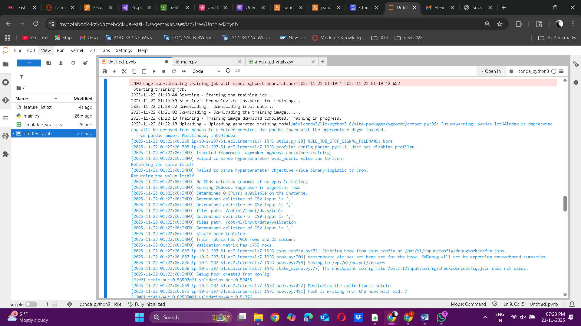  
  
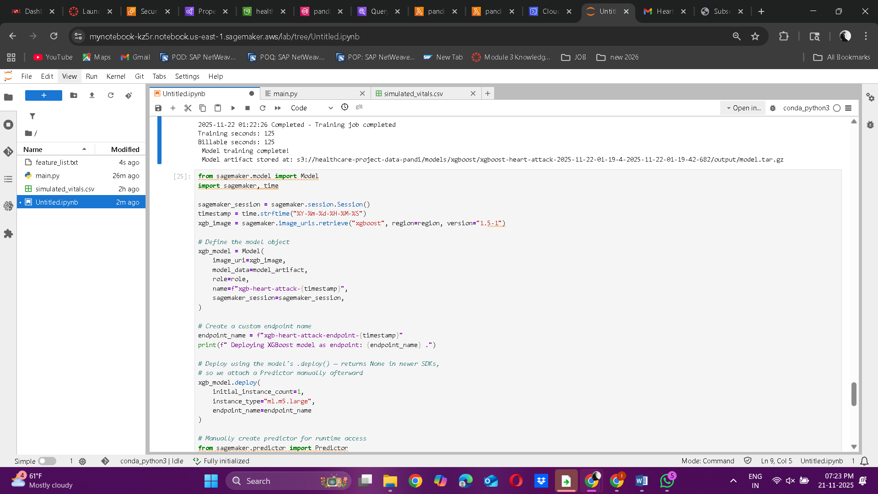  
  
**# Cell 8: Deploy the Model**  
from sagemaker.model import Model

import sagemaker, time

sagemaker_session = sagemaker.session.Session()

timestamp = time.strftime("%Y-%m-%d-%H-%M-%S")

xgb_image = sagemaker.image_uris.retrieve("xgboost", region=region, version="1.5-1")

# Define the model object

xgb_model = Model(

image_uri=xgb_image,

model_data=model_artifact,

role=role,

name=f"xgb-heart-attack-{timestamp}",

sagemaker_session=sagemaker_session,

)

# Create a custom endpoint name

endpoint_name = f"xgb-heart-attack-endpoint-{timestamp}"

print(f" Deploying XGBoost model as endpoint: {endpoint_name} .")

# Deploy using the model's .deploy() — returns None in newer SDKs,

# so we attach a Predictor manually afterward

xgb_model.deploy(

initial_instance_count=1,

instance_type="ml.m5.large",

endpoint_name=endpoint_name

)

# Manually create predictor for runtime access

from sagemaker.predictor import Predictor

predictor = Predictor(endpoint_name=endpoint_name, sagemaker_session=sagemaker_session)

print("\n Model deployed successfully!")

print(" Endpoint name:", endpoint_name)  
**Screenshot 8:**  
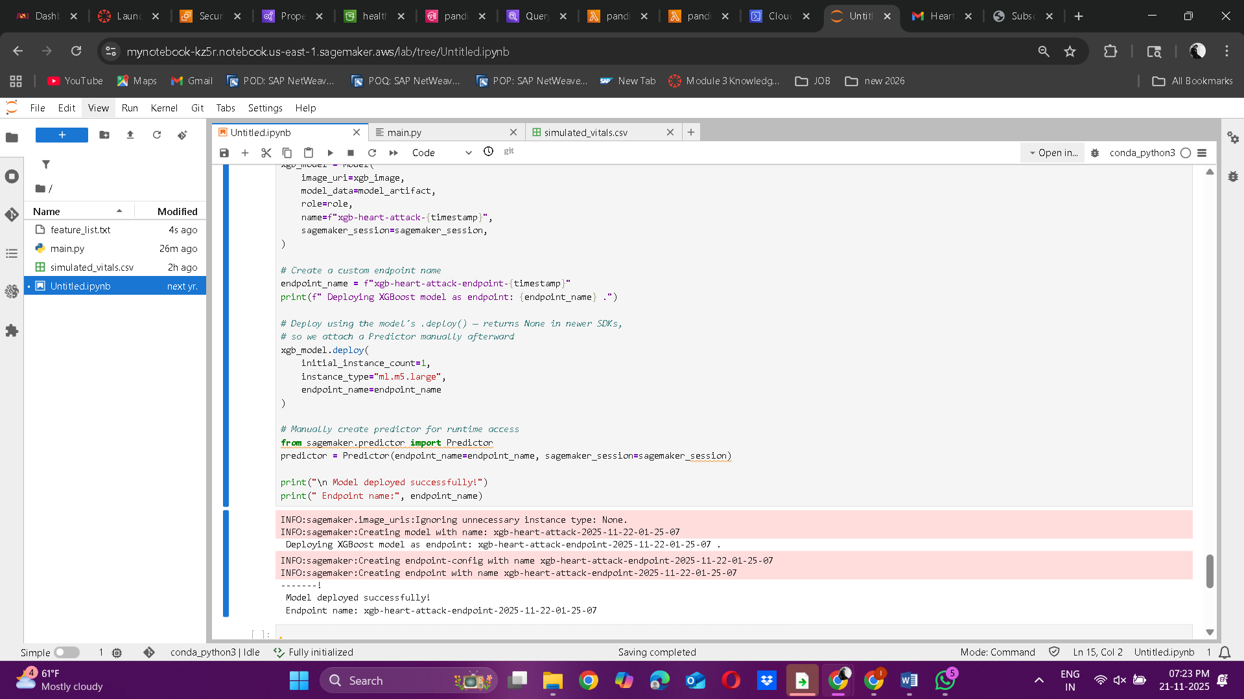  
  
 **Phase 4:**   **Set Up Automated Alerts Using Lambda + SNS  
LAMDA CODE:**  
import boto3

import csv

import io

import pandas as pd

import json

from datetime import datetime

runtime = boto3.client("sagemaker-runtime")

s3 = boto3.client("s3")

sns = boto3.client("sns")

ENDPOINT_NAME = "xgb-heart-attack-endpoint-2025-11-22-01-25-07" # Replace

BUCKET_NAME = "healthcare-project-data-pandi"

PROCESSED_PREFIX = "processed/final_health_dataset_csv/"

FEATURE_LIST_KEY = "preprocess/feature_list.txt"

ALERT_TOPIC_ARN = "arn:aws:sns:us-east-1:191794409543:pandi-health-alerts" # Replace

def load_feature_list():

    """Load expected feature list from S3."""

    obj = s3.get_object(Bucket=BUCKET_NAME, Key=FEATURE_LIST_KEY)

    features = obj["Body"].read().decode("utf-8").splitlines()

    features = [f.strip() for f in features if f.strip()]

    if "Heart Attack Risk" in features:

        features.remove("Heart Attack Risk")

    return features

def preprocess_row(df_row, expected_features):

    """Preprocess one row and align with training feature set."""

    df = pd.DataFrame([df_row])

    # Split Blood Pressure

    if "Blood Pressure" in df.columns:

        bp = df["Blood Pressure"].astype(str).str.split("/", n=1, expand=True)

        df["BP_Systolic"] = pd.to_numeric(bp[0], errors="coerce")

        df["BP_Diastolic"] = pd.to_numeric(bp[1], errors="coerce")

        df.drop(columns=["Blood Pressure"], inplace=True)

    # Drop non-feature columns

    df = df.drop(columns=["Patient ID", "Country", "Continent", "Hemisphere"], errors="ignore")

    # Manual encoding for categorical columns

    df["Sex_Male"] = (df["Sex"].astype(str).str.lower() == "male").astype(int)

    df["Diet_Healthy"] = (df["Diet"].astype(str).str.lower() == "healthy").astype(int)

    df["Diet_Unhealthy"] = (df["Diet"].astype(str).str.lower() == "unhealthy").astype(int)

    # Drop originals

    df = df.drop(columns=["Sex", "Diet"], errors="ignore")

    # Convert numeric & fill missing

    df = df.apply(pd.to_numeric, errors="coerce").fillna(0)

    # Align with expected features

    for col in expected_features:

        if col not in df.columns:

            df[col] = 0

    df = df[expected_features]

    return df

def lambda_handler(event, context):

    print("Lambda invoked. Checking for processed CSV file in S3...")

    expected_features = load_feature_list()

    print(f"Loaded {len(expected_features)} expected features from training.")

    # Get latest processed CSV

    objects = s3.list_objects_v2(Bucket=BUCKET_NAME, Prefix=PROCESSED_PREFIX)

    csv_files = [obj["Key"] for obj in objects.get("Contents", []) if obj["Key"].endswith(".csv")]

    if not csv_files:

        return {"statusCode": 404, "body": json.dumps({"error": "No CSV file found."})}

    csv_key = csv_files[0]

    print(f"Using file: {csv_key}")

    # Read CSV

    obj = s3.get_object(Bucket=BUCKET_NAME, Key=csv_key)

    data = obj["Body"].read().decode("utf-8").splitlines()

    reader = csv.DictReader(data)

    rows = list(reader)

    print(f" Columns detected ({len(reader.fieldnames)}): {reader.fieldnames}")

    results, alerts, alert_details = [], 0, []

    predictions = []

    for i, row in enumerate(rows[:50]):  # process up to 50 rows

        patient_id = row.get("Patient ID", f"Row{i+1}")

        df_row = preprocess_row(row, expected_features)

        csv_payload = df_row.to_csv(index=False, header=False)

        response = runtime.invoke_endpoint(

            EndpointName=ENDPOINT_NAME,

            ContentType="text/csv",

            Body=csv_payload

        )

        raw_result = response["Body"].read().decode("utf-8").strip()

        if raw_result:

            score = float(raw_result)

            results.append(score)

            print(f"Risk score for {patient_id}: {score:.3f}")

            predictions.append({

                "Patient ID": patient_id,

                "Heart Attack Risk": round(score, 6),

                "Risk_Status": "HIGH_RISK" if score > 0.45 else "LOW_RISK",

                "ScoredAt": datetime.utcnow().isoformat() + "Z"

            })

            if score > 0.45:  # Alert threshold

                alerts += 1

                alert_details.append({

                    "patient_id": patient_id,

                    "risk_score": round(score, 3),

                    "status": "HIGH_RISK"

                })

                print(f"High-risk alert triggered for {patient_id} (score={score:.3f})")

    # Save predictions summary to S3 (without touching original data)

    timestamp = datetime.utcnow().strftime("%Y%m%d_%H%M%S")

    pred_key = f"predictions/heart_attack_predictions_{timestamp}.csv"

    if predictions:

        df_pred = pd.DataFrame(predictions)

        csv_buf = io.StringIO()

        df_pred.to_csv(csv_buf, index=False)

        s3.put_object(Bucket=BUCKET_NAME, Key=pred_key, Body=csv_buf.getvalue().encode("utf-8"))

        print(f"Predictions saved to s3://{BUCKET_NAME}/{pred_key}")

    # SNS notification

    if alerts > 0:

        try:

            msg = "\n".join([f"{a['patient_id']}: {a['risk_score']}" for a in alert_details])

            sns.publish(

                TopicArn=ALERT_TOPIC_ARN,

                Message=f" {alerts} High-Risk Patients Detected:\n{msg}",

                Subject=" Heart Health Alert Triggered"

            )

            print(" SNS notification sent.")

        except Exception as e:

            print(f"SNS notification failed: {e}")

    print(f"Processed {len(rows)} rows, triggered {alerts} alerts.")

    return {

        "statusCode": 200,

        "body": json.dumps({

            "processed_rows": len(rows),

            "alerts_triggered": alerts,

            "alert_details": alert_details,

            "all_scores": results

        })

    }  
**screenshot:**  
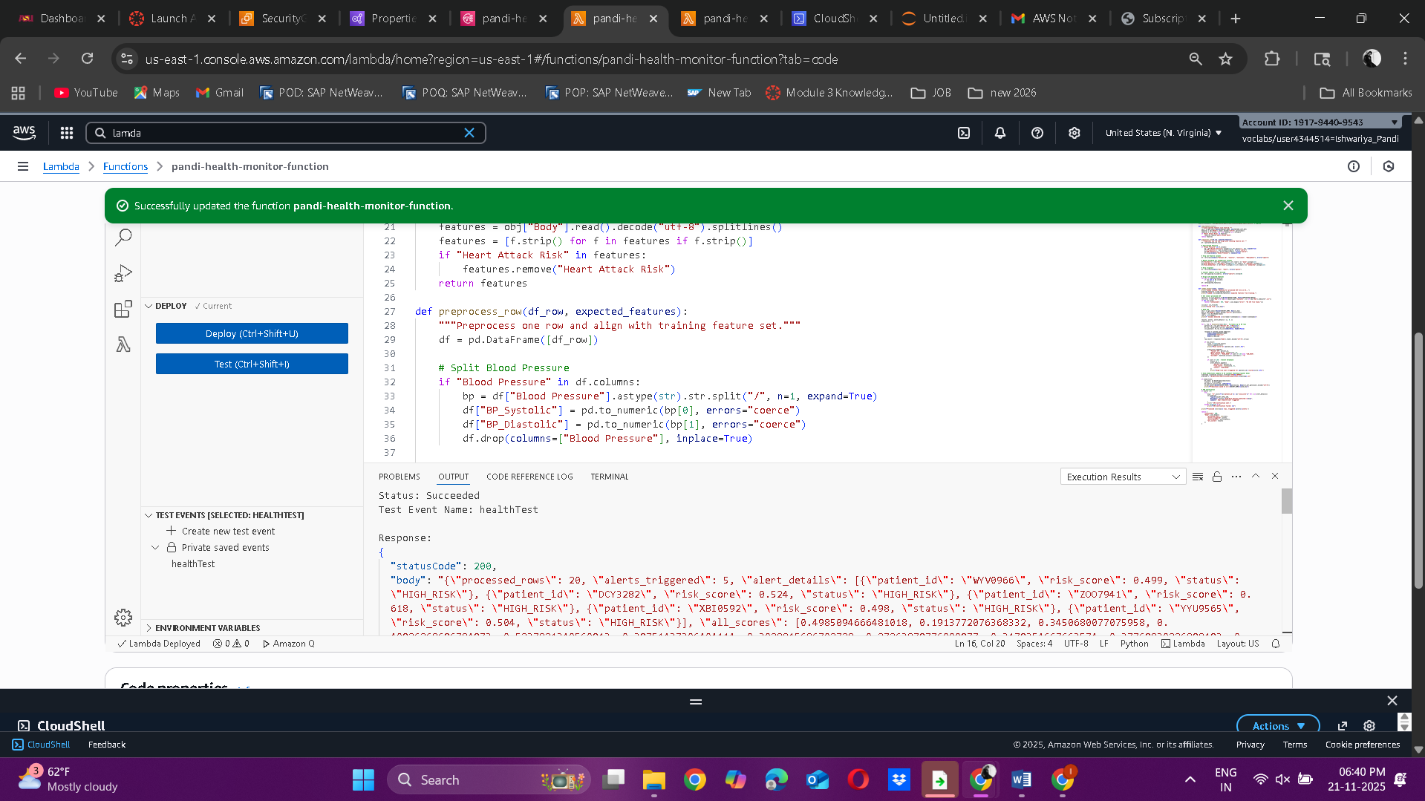  
  
**Phase 5:    Perform Data Analytics in Amazon Athena**

**Query 1:**

CREATE DATABASE IF NOT EXISTS healthcare_analysis_db;  
**screenshot:**  
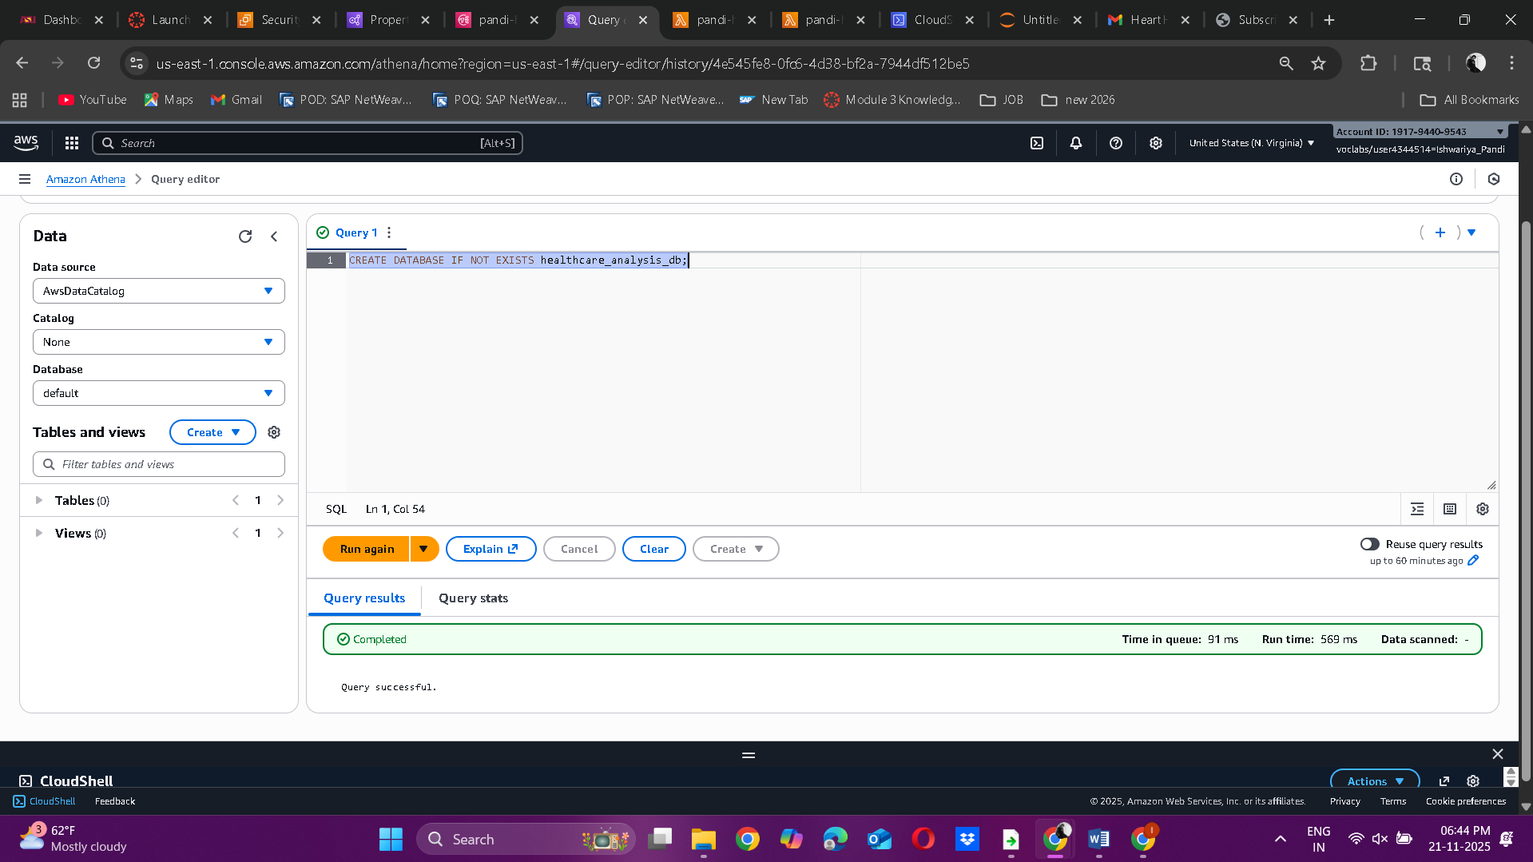

**Query 2:**

CREATE EXTERNAL TABLE IF NOT EXISTS heart_attack_processed_data (

`Patient ID` string,

`Heart Rate` double,

`Sleep Hours Per Day` double,

`Physical Activity Days Per Week` int,

`Blood Pressure` string,

`Age` int,

`Sex` string,

`Cholesterol` double,

`Diabetes` int,

`Family History` int,

`Smoking` int,

`Obesity` int,

`Alcohol Consumption` double,

`Exercise Hours Per Week` double,

`Diet` string,

`Previous Heart Problems` int,

`Medication Use` int,

`Stress Level` int,

`Sedentary Hours Per Day` double,

`Income` bigint,

`BMI` double,

`Triglycerides` int,

`Country` string,

`Continent` string,

`Hemisphere` string

)

ROW FORMAT SERDE 'org.apache.hadoop.hive.serde2.OpenCSVSerde'

WITH SERDEPROPERTIES (

"separatorChar" = ",",

"quoteChar" = "\""

)

LOCATION 's3://healthcare-project-data-pandi/processed/final_health_dataset_csv/'  
  
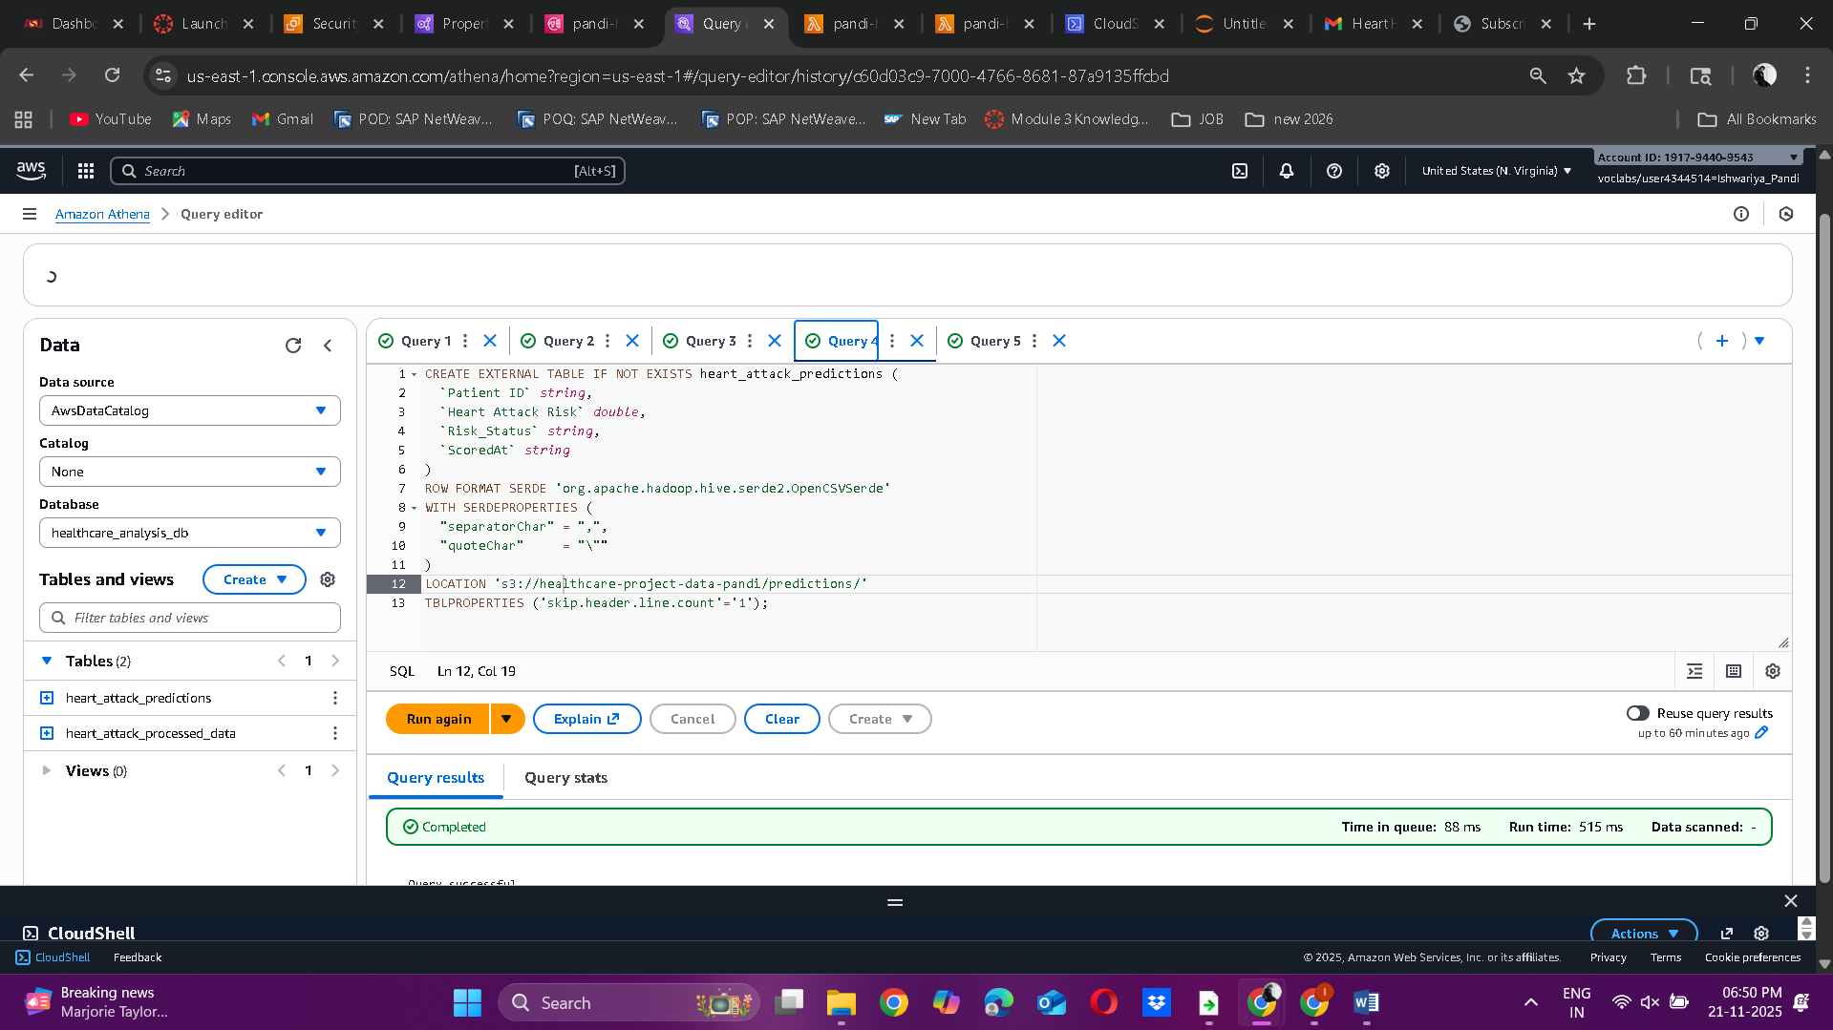  
  
  
**Query 2 Screenshot:**

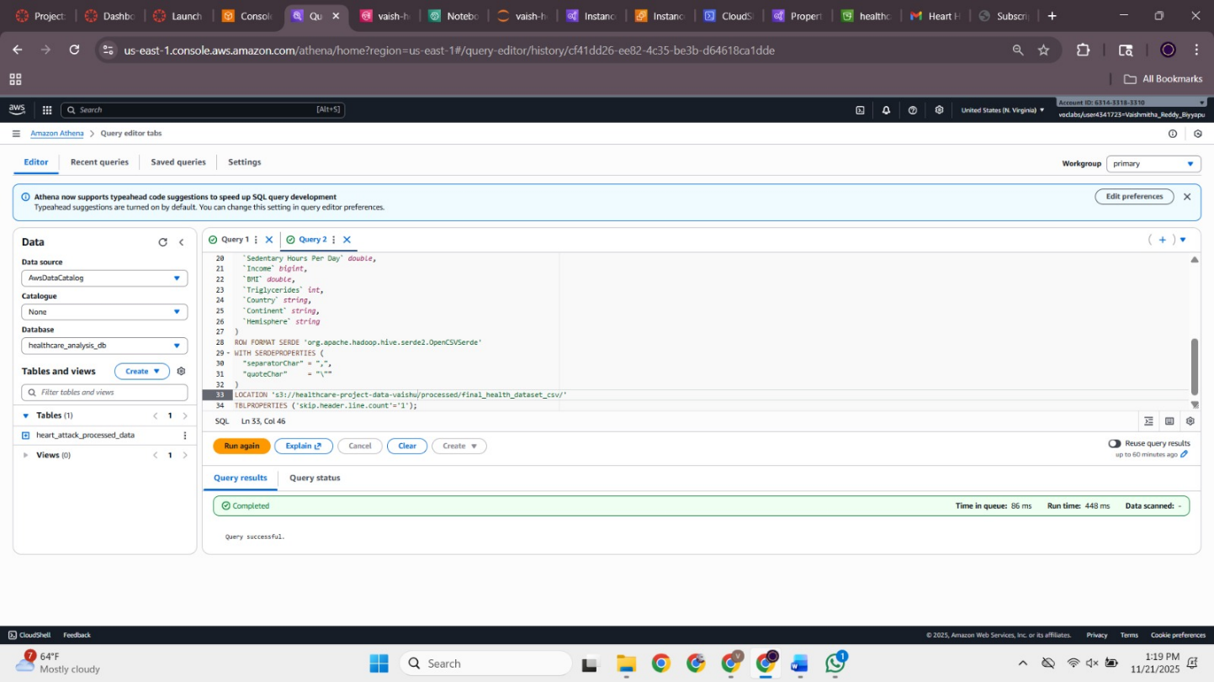

**Query 3:**

SELECT COUNT(*) FROM heart_attack_processed_data;

**Query 3 Screenshot:**

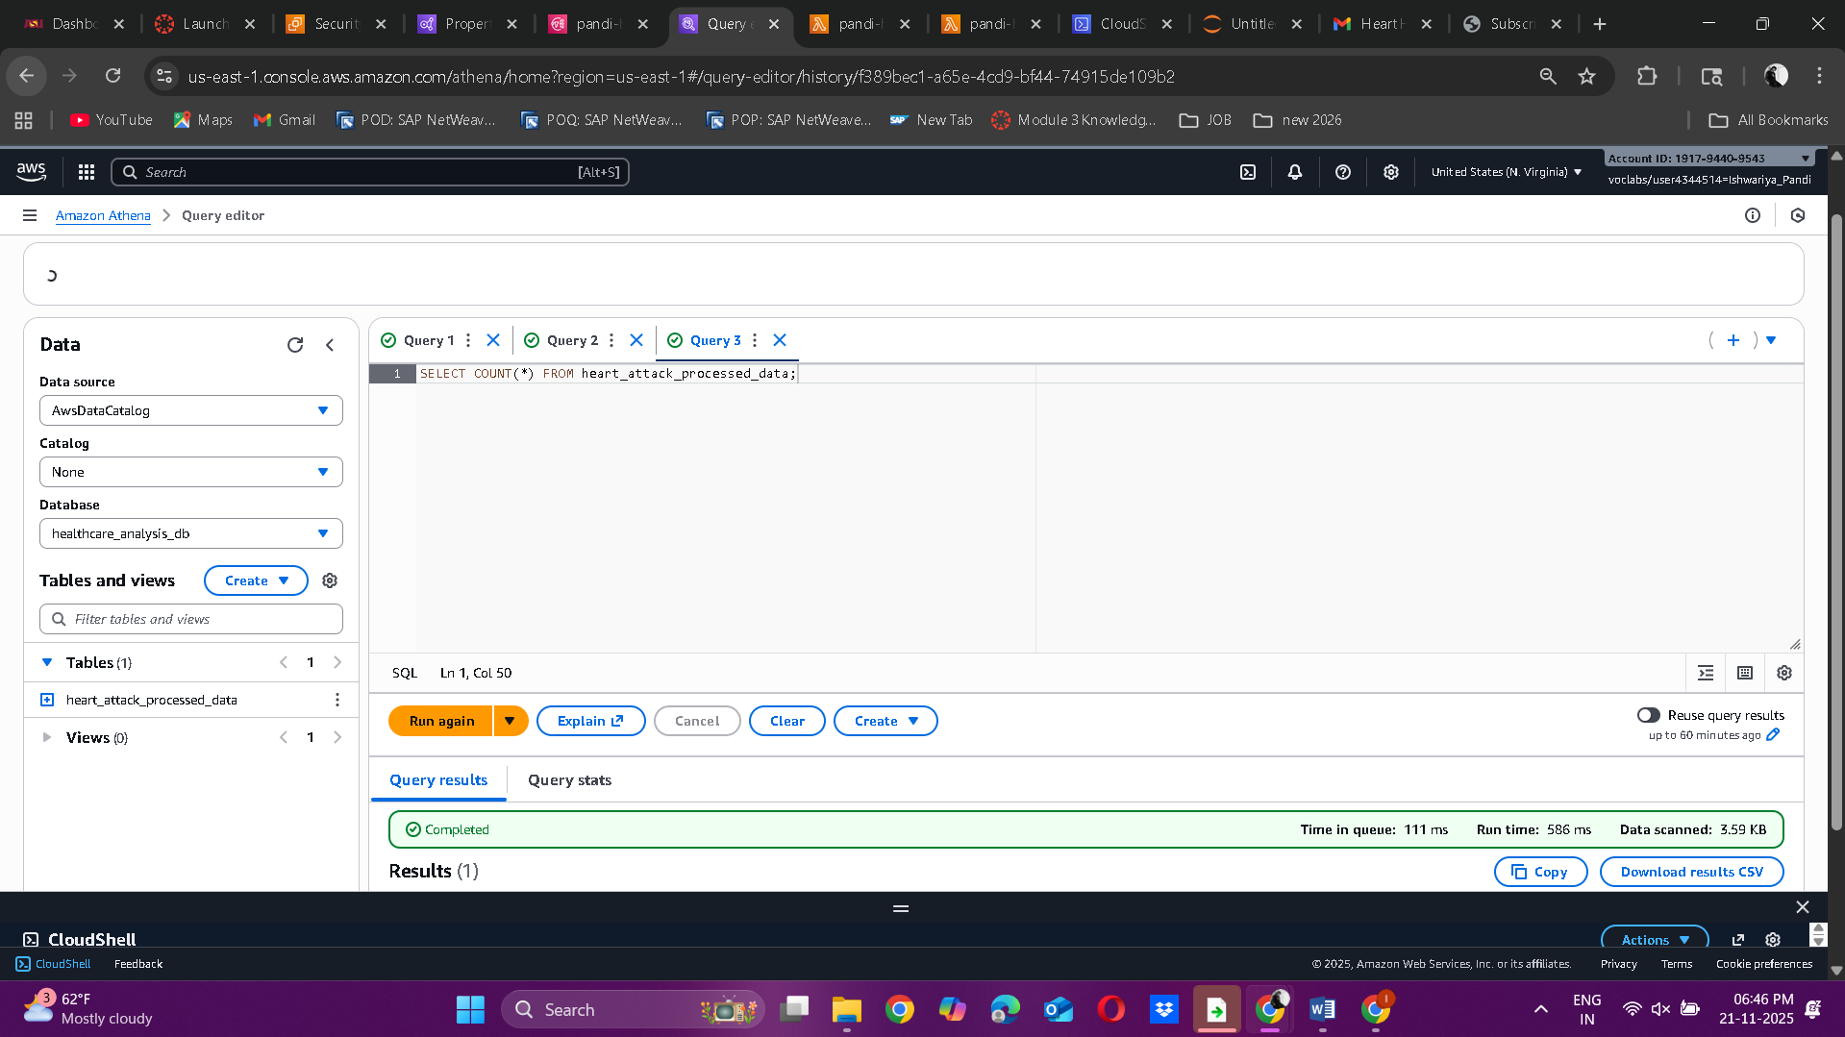

**Query 4:**

CREATE EXTERNAL TABLE IF NOT EXISTS heart_attack_predictions (

`Patient ID` string,

`Heart Attack Risk` double,

`Risk_Status` string,

`ScoredAt` string

)

ROW FORMAT SERDE 'org.apache.hadoop.hive.serde2.OpenCSVSerde'

WITH SERDEPROPERTIES (

"separatorChar" = ",",

"quoteChar" = "\""

)

LOCATION 's3://healthcare-project-data-pandi/predictions/'

TBLPROPERTIES ('skip.header.line.count'='1');

**Query 4 Screenshot:**

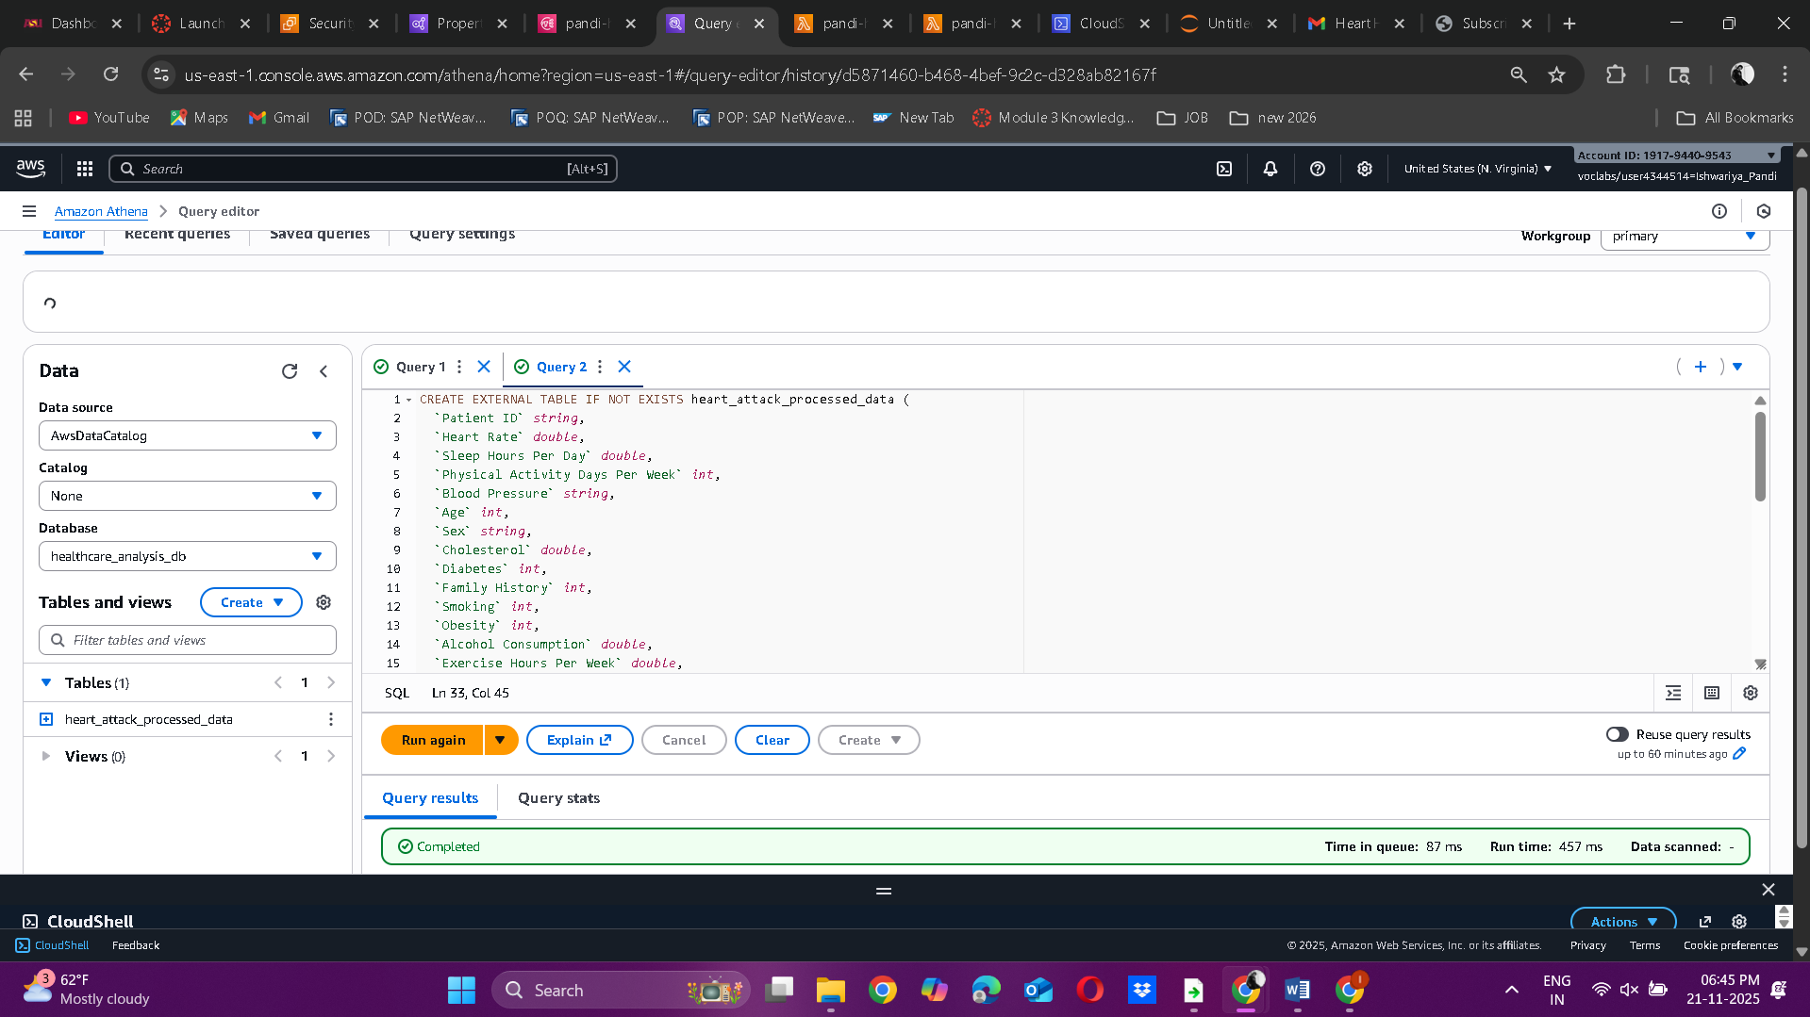

**Query 5:**

SELECT COUNT(*) FROM heart_attack_predictions;

**Query 5 Screenshot:**

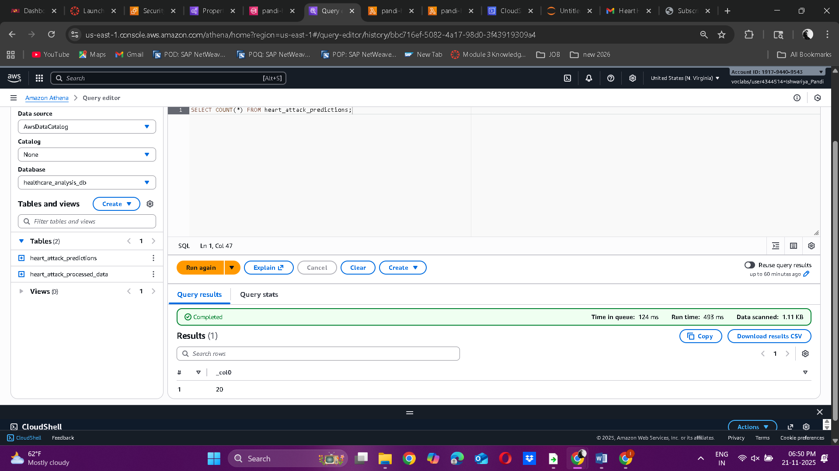

**Query 6:**

SELECT

p."Patient ID" AS patient_id,

p."Heart Attack Risk" AS predicted_risk,

p.Risk_Status,

from_iso8601_timestamp(p.ScoredAt) AS scored_at,

d.Age,

d.Sex,

d."Cholesterol",

d."Blood Pressure",

d.Country

FROM heart_attack_predictions p

LEFT JOIN heart_attack_processed_data d

ON p."Patient ID" = d."Patient ID"

ORDER BY p."Heart Attack Risk" DESC

LIMIT 200;

**Query 6 Screenshot:**



**Query 7:**

SELECT

COUNT(*) AS high_risk_count

FROM heart_attack_predictions

WHERE "Heart Attack Risk" > 0.45;

**Query 7 Screenshot:**



**Query 8:**

SELECT

CASE

WHEN d.Age < 30 THEN '20-29'

WHEN d.Age BETWEEN 30 AND 39 THEN '30-39'

WHEN d.Age BETWEEN 40 AND 49 THEN '40-49'

WHEN d.Age BETWEEN 50 AND 59 THEN '50-59'

WHEN d.Age BETWEEN 60 AND 69 THEN '60-69'

ELSE '70+'

END AS age_group,

ROUND(AVG(p."Heart Attack Risk"), 3) AS avg_predicted_risk,

COUNT(*) AS patients

FROM heart_attack_predictions p

JOIN heart_attack_processed_data d

ON p."Patient ID" = d."Patient ID"

GROUP BY

CASE

WHEN d.Age < 30 THEN '20-29'

WHEN d.Age BETWEEN 30 AND 39 THEN '30-39'

WHEN d.Age BETWEEN 40 AND 49 THEN '40-49'

WHEN d.Age BETWEEN 50 AND 59 THEN '50-59'

WHEN d.Age BETWEEN 60 AND 69 THEN '60-69'

ELSE '70+'

END

ORDER BY age_group;

**Query 8 Screenshot:** **Query 9:**

SELECT

FLOOR(d."Sleep Hours Per Day") AS sleep_hours_floor,

ROUND(AVG(d."Sleep Hours Per Day"), 2) AS avg_sleep,

ROUND(AVG(p."Heart Attack Risk"), 3) AS avg_predicted_risk,

COUNT(*) AS patients

FROM heart_attack_predictions p

JOIN heart_attack_processed_data d

ON p."Patient ID" = d."Patient ID"

GROUP BY FLOOR(d."Sleep Hours Per Day")

ORDER BY sleep_hours_floor;

**Query 9 Screenshot:**  


**Query 10:**

SELECT

ROUND(AVG(d."Physical Activity Days Per Week"), 2) AS avg_activity_days,

ROUND(AVG(d."Heart Rate"), 1) AS avg_heart_rate,

ROUND(AVG(p."Heart Attack Risk"), 3) AS avg_predicted_risk

FROM heart_attack_predictions p

JOIN heart_attack_processed_data d

ON p."Patient ID" = d."Patient ID";

**Query 10 Screenshot:**

 **e. Project workflow**

The workflow of this project follows a clear and organized sequence of steps to create a complete automated machine learning system. It starts with **data ingestion**, where raw healthcare data is collected and stored in **Amazon S3**. The next stage is **data preprocessing**, which includes cleaning the data, fixing missing values, splitting combined fields like blood pressure, converting text columns into numeric ones, creating new features, and saving the final cleaned dataset back to S3.

After the data is prepared, the process moves to **model development** in **Amazon SageMaker**, where the cleaned dataset is used to train an **XGBoost** model that predicts heart attack risk. The best-performing model is then deployed as a real-time SageMaker endpoint that can make live predictions.

Following deployment, an **AWS Lambda** function is created to automate the prediction process. It retrieves the latest processed CSV file from S3, applies the same preprocessing steps, and sends the data to the deployed SageMaker endpoint for scoring. The Lambda function compares each prediction to a fixed risk threshold and saves the results in a timestamped file in S3. If high-risk patients are detected, the Lambda function automatically sends alerts to healthcare providers through **Amazon SNS**.

Throughout the entire process, **Amazon CloudWatch** tracks logs and metrics for auditing and monitoring. Together, these steps form a seamless, scalable end-to-end machine learning pipeline that combines data storage, preprocessing, training, deployment, automation, and real-time alerting.

**Project Video**

**Google drive link:** [**https://drive.google.com/file/d/1Dufiq7PPVSJvQpnGvwFblkigo6T0HkJ5/view?usp=drive_link**](https://drive.google.com/file/d/1Dufiq7PPVSJvQpnGvwFblkigo6T0HkJ5/view?usp=drive_link)